Table of Contents
- Overview
- Ecosystem
  - Component
  - Reducer and Forward Dispatcher
  - Actions and Updaters
  - Processors and Schema Manager
- Get Started
- Advanced Usage
  - Using reducer plugin
  - Custom reducer initial state
  - Using updaters to modify kepler.gl state
  - Forward actions
  - Saving and loading maps with schema manager
  - Replace UI component
  - Custom Mapbox Host
  - Custom Map Styles
  - Localization
- API
  - Components
  - Reducers
  - Actions and Updaters
  - Data Processor
  - Schemas

Overview
Kepler.gl is a Redux-connected component. You can embed kepler.gl in your App, which uses redux to manage its state. The basic implementation of kepler.gl reducer is simple. However, to make the most of it, it's recommended to have basic knowledge on:
- React
- Redux state container
- React Redux connect
To start out with kepler.gl, you simply need to add the Kepler.gl UI component and mount the Kepler.gl reducer. To give the user full access of all the functionalities of kepler.gl, this package also includes actions, schema managers and a set of utilities to load and save map data.

Ecosystem
The diagram below represents the data flow. Note that in most cases, you don't have to worry about action creators, forward dispatcher and state updaters, as they are handled under-the-hood by kepler.gl
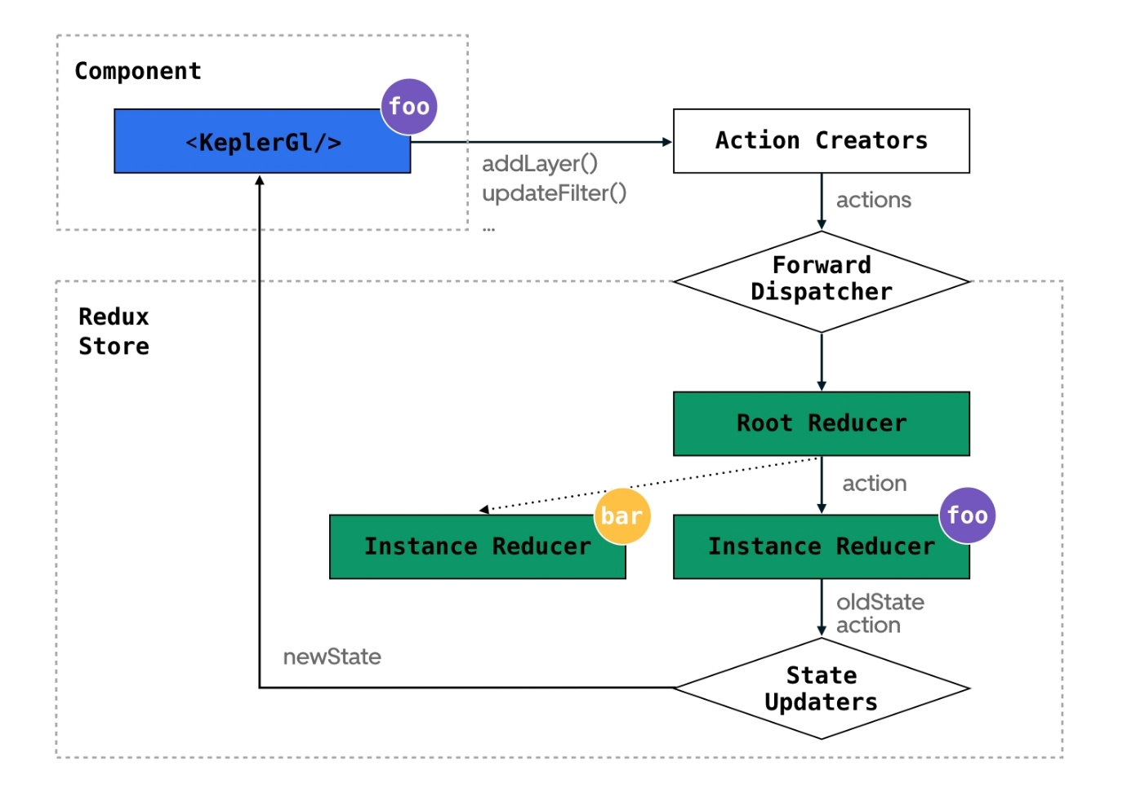

Component
The Kepler.gl component will call redux connect under the hood, and dispatch to the corresponding reducer instance.
To allow mounting of multiple instance of kepler.gl components in the same app, we implemented a local selector with forward dispatch system. The local selector will pass down the knowledge where the state of this instance lives, and the forward dispatch system will pass down a dispatch function that knows to dispatch action to the correct reducer instance. Each kepler.gl component instance needs to have an unique id.
Read more about Component.

Reducer and Forward Dispatcher
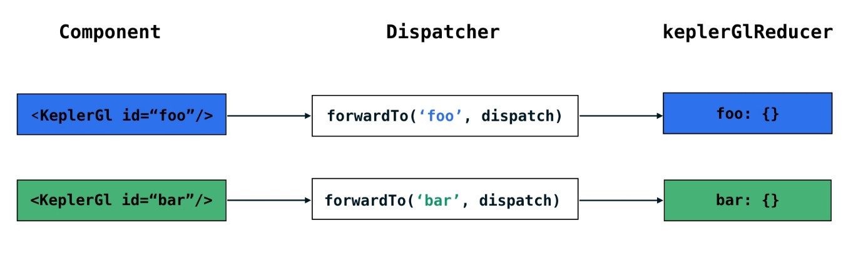
The kepler.gl root reducer that user mounted in their app is in fact a wrapper reducer that stored the child state and update them based on forwarded actions. If An action is not a forwarded action, it pass down to all child reducers.
When a KeplerGl component instance is mounted with the id foo, the wrapper reducer will add a kepler.gl local state in the root state at key foo.
One of the biggest challenge of using local state is to dispatch actions that only modify a specific local state. For instance, if we have 2 kepler.gl components in our app, one with id foo other with id bar. Our keplerGl reducer is going to be keplerGl: {foo: …, bar …}. When foo dispatches an action, it only needs to update the state of foo, we need a way to decorate the action that the root reducer only pass it down to subreducer foo.
To solve this, kepler.gl has a forward dispatching system. It consists of a set of forward functions including wrapTo, forwardTo and unwrap. wrapTo wraps an action payload into an forward action by adding an address _addr_ and a _forward_ signature to its meta.
Each kepler.gl component receives a forward dispatcher as a prop, which dispatches a forwarded action to the root reducer. The root reducer will check if the given action has that address and if so, unwrap the action and pass it to the child reducer.
Read more about Reducers.

Actions and Updaters
Actions in reducers are mapped to state transition functions. UPDATE_MAP is mapped to updateMapUpdater. An updater is the backbone of the redux reducer. It is a pure function that takes the previous state and an action, and returns the next state. (oldState, action) => newState. It describes how the state should transition upon receiving that action.
here is a snippet of the map state reducer in kepler.gl.
Copy
/* Action Handlers */
const actionHandler = {
};

/* Reducer */
export default handleActions(actionHandler, INITIAL_MAP_STATE);
This pattern allows a user to import a specific action updater in the app's root reducer and use it to directly modify kepler.gl’s state without dispatching the action. This will give user a lot of freedom to control over kepler.gl's state transition.
Read more about Actions and Updaters.

Processors and Schema Manager
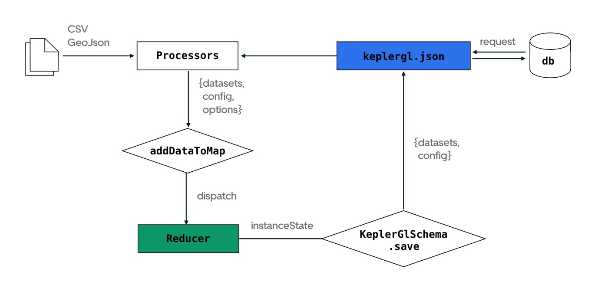
Processors and schema manager are useful helpers to get data in and out of kepler.gl. You can use processCsvData(csv) and processGeojson(geojson) to parse csv or geoJson file and pass it to addDataToMap() action.
To save and reload the current map, you can call KeplerGlSchema.save() and pass it the instant state. It will return a json output containing map data and config. Pass this json file to processKeplerglJSON() and then addDataToMap() will reproduce the same map.

Get Started

Installation
Use Node v18 and above, older node versions have not been tested
Copy
npm install --save kepler.gl @kepler.gl/components @kepler.gl/reducers

Get Mapbox Token
Kepler.gl is built on top of Mapbox GL. A mapbox account and an access token are needed to use kepler.gl in your app. Get a Mapbox Access Token at mapbox.com.

Basic Usage
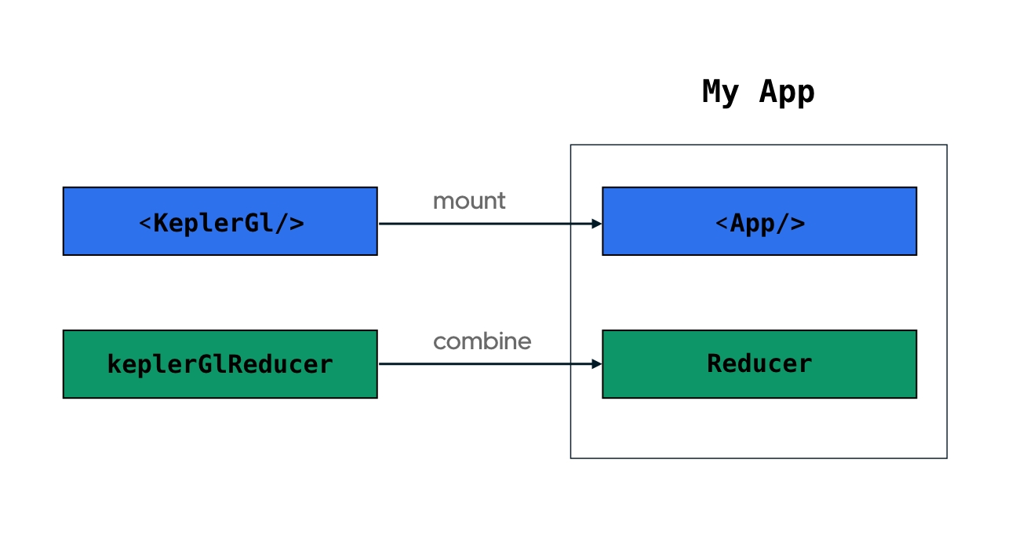
Basic Usage

0. Working Template
Check full example on Github.
Copy
import * as React from "react";
import ReactDOM from "react-dom/client";
import document from "global/document";

import { applyMiddleware, combineReducers, compose, createStore } from "redux";
import { connect, Provider } from "react-redux";

import keplerGlReducer, { enhanceReduxMiddleware } from "@kepler.gl/reducers";
import KeplerGl from "@kepler.gl/components";

import AutoSizer from "react-virtualized/dist/commonjs/AutoSizer";

const reducers = combineReducers({
keplerGl: keplerGlReducer.initialState({
uiState: {
readOnly: false,
currentModal: null,
},
}),
});

const middleWares = enhanceReduxMiddleware([
// Add other middlewares here
]);

const enhancers = applyMiddleware(...middleWares);

const initialState = {};
const store = createStore(reducers, initialState, compose(enhancers));

const App = () => (
<div
style={{
position: "absolute",
top: "0px",
left: "0px",
width: "100%",
height: "100%",
}}
>
<AutoSizer>
{({ height, width }) => (
<KeplerGl
mapboxApiAccessToken="xxx" // Replace with your mapbox token
id="map"
width={width}
height={height}
/>
)}
</AutoSizer>
</div>
);

const mapStateToProps = (state) => state;
const dispatchToProps = (dispatch) => ({ dispatch });
const ConnectedApp = connect(mapStateToProps, dispatchToProps)(App);
const Root = () => (
<Provider store={store}>
<ConnectedApp />
</Provider>
);

export default Root;

1. Mount reducer
Kepler.gl uses Redux to manage its internal state, along with react-palm middleware to handle side effects. Mount kepler.gl reducer in your store, apply taskMiddleware.
Copy
import keplerGlReducer from '@kepler.gl/reducers';
import {createStore, combineReducers, applyMiddleware} from 'redux';
import {taskMiddleware} from 'react-palm/tasks';

const reducer = combineReducers({
// <-- mount kepler.gl reducer in your app
keplerGl: keplerGlReducer,

// Your other reducers here
app: appReducer
});

// create store
const store = createStore(reducer, {}, applyMiddleware(taskMiddleware));
If you mount keplerGlReducer in another address instead of keplerGl, or it is not mounted at root of your reducer, you will need to specify the path to it when you mount the component with the getState prop.

2. Mount component
Copy
import KeplerGl from '@kepler.gl/components';

const Map = props => (
<KeplerGl
id="foo"
mapboxApiAccessToken={token}
width={width}
height={height}/>
);

3. Add data to map
In order to interact with a kepler.gl instance and add new data to it, you can dispatch the addDataToMap action from anywhere inside your app. It adds dataset(s) to a kepler.gl instance and updates the full configuration (mapState, mapStyle, visState).
Read more about addDataToMap
Copy
import {addDataToMap} from '@kepler.gl/actions';

this.props.dispatch(
addDataToMap({
// datasets
datasets: {
info: {
label: 'Sample Taxi Trips in New York City',
id: 'test_trip_data'
},
data: sampleTripData
},
// option
option: {
centerMap: true,
readOnly: false
},
// config
config: {
mapStyle: {styleType: 'light'}
}
})
);

Saving and Loading Maps with Schema Manager

Processor and Schema
Kelper.gl provides a schema manager to save and load maps. It converts current map data and configuration into a smaller JSON blob. You can then load that JSON blob into an empty map by passing it to addDataToMap.
The reason kepler.gl provides a Schema manager is to make it easy for users to connect the kepler.gl client app to any database, saving map data / config and later load it back. With the schema manager, a map saved in an older version can still be parsed and loaded with the latest kepler.gl library.

Save map
Pass the instanceState to SchemaManager.save()
- SchemaManager.save() will output a JSON blob including data and config.
Under the hood, SchemaManager.save() calls SchemaManager.getDatasetToSave() and SchemaManager.getConfigToSave()
- SchemaManager.getDatasetToSave() will output an array of dataset.
- SchemaManager.getConfigToSave() will output a JSON blob of the current config.
In the example blow, foo is the id of the KeplerGl instance to be save.
Copy
import KeplerGlSchema from '@kepler.gl/schemas';

const mapToSave = KeplerGlSchema.save(state.keplerGl.foo);
// mapToSave = {datasets: [], config: {}, info: {}};

const dataToSave = KeplerGlSchema.getDatasetToSave(state.keplerGl.foo);
// dataToSave = [{version: '', data: {id, label, color, allData, fields}}]

const configToSave = KeplerGlSchema.getConfigToSave(state.keplerGl.foo);
// configToSave = {version: '', config: {}}

Load map
Pass saved data and config to SchemaManager.load()
- SchemaManager.load() will parsed saved config and data, apply version control, the output can then be passed to addDataToMap directly.
Under the hood, SchemaManager.load() calls SchemaManager.parseSavedData() and SchemaManager.parseSavedConfig()
- SchemaManager.parseSavedData() will output an array of parsed dataset.
- SchemaManager.parseSavedConfig() will output a JSON blob of the parsed config.
Copy
import KeplerGlSchema from '@kepler.gl/schemas';
import {addDataToMap} from '@kepler.gl/actions';

const mapToLoad = KeplerGlSchema.load(savedDatasets, savedConfig);
// mapToLoad = {datasets: [], config: {}};

this.props.dispatch(addDataToMap(mapToLoad));

Match config with another dataset
Often times, people want to keep a map config as template, then load it with different datasets. To match a config with a different dataset, you need to make sure data.id in the new dataset matches the old one.
Copy
import KeplerGlSchema from '@kepler.gl/schemas';
import {addDataToMap} from '@kepler.gl/actions';

// save current map data and config
const {datasets, config} = KeplerGlSchema.save(state.keplerGl.foo);
// mapToLoad = {datasets: [], config: {}};

// receive some new data
const newData = someNewData;
// newData = [{rows, fields}]

// match id with old datasets
const newDatasets = newData.map((d, i) => ({
version: datasets[i].version,
data: {
...datasets[i].data,
allData: d.rows,
fields: d.fields
}
}));

// load config with new datasets
const mapToLoad = KeplerGlSchema.load(newDatasets, config);

this.props.dispatch(addDataToMap(mapToLoad));

Replace UI Component with Component Dependency Injection
To allow customize a child component, the library author usually has to pass the child component down as a prop from top of the component tree. This approach will work for component that are relatively small, but it won’t scale for kepler.gl because it has hundreds of child components. To give user the flexibility to render certain component differently. Kepler.gl has a dependency injection system that allows user to inject custom components to kepler.gl UI replacing the default ones at bootstrap time.
All you need to do is to create a component factory for the one you wish to replace, import the original component factory and call injectComponents at where KeplerGl is mounted. injectComponents will return a new KeplerGl component instance that renders the custom child component. This way we don’t have to keep track of hundreds of component as props and pass them all the way down. Dependency injection only happens once when keplerGl component is imported.

Factory
For each high level component in kepler.gl, we export a factory. A factory is a function that takes a set of dependencies and return a component instance. In this example below, the MapContainerFactory takes MapPopover and MapControl as dependencies and returns the MapContainer component instance. Not all components are exported as factories in kepler.gl at the moment, we are still testing this feature.
Copy
import MapPopoverFactory from 'components/map/map-popover';
import MapControlFactory from 'components/map/map-control';

function MapContainerFactory(MapPopover, MapControl) {
return class MapContainer extends Component {
render() {
return (
<div>
<MapPopover {...popoverProps} />
<MapControl {...controlProps} />
</div>
);
}
}
}

MapContainerFactory.deps = [MapPopoverFactory, MapControlFactory];

Recipes
A recipe is an array of default factory, and the one to replace it. [defaultFactory, customFactory]. To replace default component, user can import the existing component factory, call injectComponents and pass in the new recipe to get a new KeplerGl instance.

Inject Components
In kepler.gl, we create the app injector by calling provide with an array of default recipes. We then export a injectComponents function that user can call to inject a different recipe and returns a new kepler.gl instance.
Here is an example of how to use injectComponents to replace default PanelHeader.
Copy
import {injectComponents, PanelHeaderFactory} from '@kepler.gl/components';

// define custom header
const CustomHeader = () => (<div>My kepler.gl app</div>);

// create a factory
const myCustomHeaderFactory = () => CustomHeader;

// Inject custom header into Kepler.gl,
const KeplerGl = injectComponents([
[PanelHeaderFactory, myCustomHeaderFactory]
]);

// render KeplerGl, it will render your custom header
const MapContainer = () => <KeplerGl id="foo"/>;

Pass custom component props
injectComponents allows user to render custom component, however, they usually also want to pass additional props to the customized component which current component injector doesn’t support. To enable passing additional props, we implemented a withStatehelper that passes additional props to the customized component. withState takes 3 arguments: lenses, mapStateToProps and actionCreators, They allows user to pass in kepler.gl instance state, state from other part of the app, and custom actions.
- lense - A getter function to get a piece of kepler.gl subreducer state. Kepler.gl exports lenses for all its sub-reducers. For instance when pass mapStateLens to withState, the component will receive mapState of current kepler.gl instance as a prop.
- mapStateToProps - A wild card to play. You can pass a mapStateToProps function to get the state from any part of the app. If the lenses aren’t enough, use mapStateToProps.
- actions - action creators that will be passed to bindActionCreators.
Here is an example of using withState helper to add reducer state and actions to customized component as additional props.
Copy
import {withState, injectComponents, PanelHeaderFactory} from '@kepler.gl/components';
import {visStateLens} from '@kepler.gl/reducers';

// custom action wrap to mounted instance
const addTodo = (text) => ({
type: 'ADD_TODO',
text
});

// define custom header
const CustomHeader = ({visState, todos, addTodo}) => (
<div onClick={() => addTodo('say hello')}>{`${Object.keys(visState.datasets).length} dataset loaded`}</div>
);

// now CustomHeader will receive `visState` `todos` and `addTodo` as additional props.
const myCustomHeaderFactory = () => withState(
// subreducer lenses
[visStateLens],

// mapStateToProps
state => ({
todos: state.todos
}),

// actions
{addTodo}
)(CustomHeader);

Forward Dispatch Actions
One of the biggest challenge of using local state is to dispatch actions that only modify a specific instance of the state. For instance, if we have 2 kepler.gl components in our app, one with id foo other with id bar. Our keplerGl reducer is going to be keplerGl: {foo: …, bar …}. When foo dispatches an action, it only needs to update the state of foo, hence we need a way to decorate the action that the root reducer only pass it down to instance reducer foo. To solve this, we provide a set of forward functions called wrapTo, forwardTo and unwrap. wrapTo wraps an action payload into an forward action by adding an address _addr_ and a _forward_ signature to its meta. The root reducer will check if the given action has that address and if so, unwrap the action and pass it to the correct instance reducer.
Here are the different options to dispatch forwarded actions to kepler.gl reducer.

1. Use forwardTo to add a dispatch function to your component
You can add a dispatch function to your component that dispatches actions to a specific kepler.gl instance using connect.
Copy
// component
import {KeplerGl} from '@kepler.gl/components';
import {connect} from 'react-redux';

// import action and forward dispatcher
import {toggleFullScreen, forwardTo} from '@kepler.gl/actions';

const MapContainer = props => (
<div>
<button onClick={() => props.keplerGlDispatch(toggleFullScreen())}/>
<KeplerGl
id="foo"
/>
</div>
)

const mapStateToProps = state => state
const mapDispatchToProps = (dispatch, props) => ({
dispatch,
keplerGlDispatch: forwardTo(‘foo’, dispatch)
});

export default connect(
mapStateToProps,
mapDispatchToProps
)(MapContainer);

  - Use wrapTo to wrap action creator
You can also simply wrap an action into a forward action with the wrapTo helper
Copy
// component
import {KeplerGl} from '@kepler.gl/components';

// action and wrapper
import {toggleFullScreen, wrapTo} from '@kepler.gl/actions';

// create a function to wrapper action payload to 'foo'
const wrapToMap = wrapTo('foo');
const MapContainer = ({dispatch}) => (
<div>
<button onClick={() => dispatch(wrapToMap(toggleFullScreen())} />
<KeplerGl id="foo"/>
</div>
);

Reducer Plugin
For advanced users, who want to add additional action handler to kepler.gl reducer, kepler.gl provides a reducer plugin function. Reducer.plugin will take additional action handlers and return a new reducer function. Plugin is only meant to be called where the store is initialized. The state passed into the additional action handler is the instance state.
Reducer.plugin will allow advanced users to extend the kepler.gl reducer behavior. Here is an example of adding an additional action HIDE_AND_SHOW_SIDE_PANEL handler that modifies the uiState.
Copy
import {combineReducers} from 'redux';
import keplerGlReducer from '@kepler.gl/reducers';

const customizedKeplerGlReducer = keplerGlReducer
.plugin({
HIDE_AND_SHOW_SIDE_PANEL: (state, action) => ({
...state,
uiState: {
...state.uiState,
readOnly: !state.uiState.readOnly
}
})
});

const reducers = combineReducers({
keplerGl: customizedKeplerGlReducer,
app: appReducer
});
Note that, reducer plugin should not be used to override default kepler.gl actions The following code will not change SET_FILTER, because plugins are handled after default actions.
Copy
const customizedKeplerGlReducer = keplerGlReducer
.plugin({
[ActionTypes.SET_FILTER]: (state, action) => state
});
For full implementation, take a look at the custom reducer example

Using Updaters
Updaters are state transition functions that mapped to actions. One action can map to multiple state updaters, each belongs to a subreducer.
This action-updater pattern allows a user to import a specific action updater in the app's root reducer and use it to directly modify kepler.gl’s state without dispatching the action. This will give user a lot of freedom to control over kepler.gl's state transition.
To achieve the same result with togglePerspective updating kepler.gl's map perspective mode. You can import and dispatch kepler.gl action togglePerspective:
Copy
// action and forward dispatcher
import {togglePerspective} from '@kepler.gl/actions';

const MapContainer = ({dispatch}) => (
<div>
<button onClick={() => dispatch(togglePerspective())} />
<KeplerGl id="foo"/>
</div>
);
or import the corresponding updater mapStateUpdaters.togglePerspectiveUpdater and call it inside the root reducer. The example below demos how to add a button outside kepler.gl component, and update the map perspective when click it.
Copy
import keplerGlReducer, {mapStateUpdaters} from '@kepler.gl/reducers';

// Root Reducer
const reducers = combineReducers({
keplerGl: keplerGlReducer,
app: appReducer
});

const composedReducer = (state, action) => {
switch (action.type) {
case 'CLICK_BUTTON':
return {
...state,
keplerGl: {
...state.keplerGl,
foo: {
...state.keplerGl.foo,
mapState: mapStateUpdaters.togglePerspectiveUpdater(
t state.keplerGl.foo.mapState
)
}
}
};
}
return reducers(state, action);
};

export default composedReducer;

Custom reducer initial state
For advanced users who wish to modify the initial state of kepler.gl reducer, kepler.gl provides a reducer initialState function. Reducer.initialState will take the custom state and return a new reducer function. initialState is only meant to be called where the store is initialized. The custom state passed in will be shallow merged with the default initialState.
Here is an example modify uiState initialState to hide side panel, and selectively display map control button.
Copy
import {combineReducers} from 'redux';
import {keplerGlReducer} from '@kepler.gl/reducers';

const customizedKeplerGlReducer = keplerGlReducer
.initialState({
uiState: {
// hide side panel to disallow user customize the map
readOnly: true,

// customize which map control button to show
mapControls: {
visibleLayers: {
show: false
},
mapLegend: {
show: true,
active: true
},
toggle3d: {
show: false
},
splitMap: {
show: false
}
}
}
});

const reducers = combineReducers({
keplerGl: customizedKeplerGlReducer,
app: appReducer
});
For full implementation, take a look at the custom reducer example

custom-mapbox-host

1. Configuring Mapbox API hostname
The KeplerGL component accepts an optional parameter mapboxApiUrl to override the default value of https://api.mapbox.com.
Copy
<KeplerGl
id="foo"
mapboxApiAccessToken={token}
mapboxApiUrl={"https://api.mapbox.cn"}
width={width}
height={height}/>

2. Overriding the default MapStyles
The default MapStyles KeplerGL uses might not be accessible to you, in this case you will need to provide MapStyle overrides. During construction of your component:
Copy
this.token = '';
this.apiHost = "https://api.mapbox.cn";
this.mapStyles = [
{
id: 'dark',
label: 'Dark Streets 9',
url: 'mapbox://styles/mapbox/dark-v9',
icon: `${this.apiHost}/styles/v1/mapbox/dark-v9/static/-122.3391,37.7922,9.19,0,0/400x300?access_token=${this.token}&logo=false&attribution=false`,
layerGroups: [] // DEFAULT_LAYER_GROUPS
},
{
id: 'light',
label: 'Light Streets 9',
url: 'mapbox://styles/mapbox/light-v9',
icon: `${this.apiHost}/styles/v1/mapbox/light-v9/static/-122.3391,37.7922,9.19,0,0/400x300?access_token=${this.token}&logo=false&attribution=false`,
layerGroups: [] // DEFAULT_LAYER_GROUPS
}
];
and In render:
Copy
<KeplerGl
id="foo"
mapboxApiAccessToken={this.token}
mapboxApiUrl={}
mapStyles={this.mapStyles}
width={width}
height={height}/>

Reducers

Reducers
Kepler.gl is a redux-connected component that utilizes redux to manage its state. The basic implementation of kepler.gl reducer is simple. However, to make the most of it, it's recommended to have basic knowledge on:
- Redux state container
- React
- React Redux connect
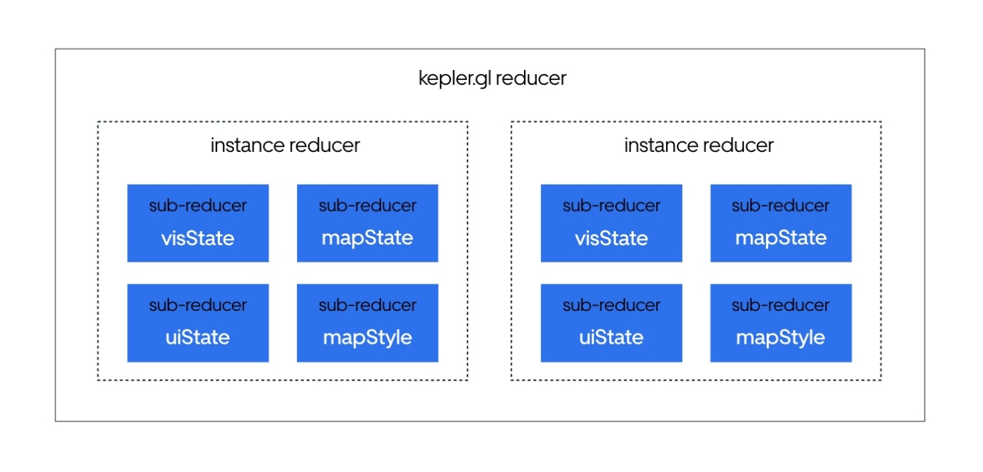
Compose-reducer
It is immportant to understand the relationship between kepler.gl reducer, instance reducer and subreducer. Kepler.gl reducer is the root reducer that combines multiple instance reducer, which manages the state of each individual kepler.gl component. The instance reducer is consists of 4 subreducers, each manages an independent part of the state.

KeplerGl Reducer
To connect kepler.gl components to your Redux app you'll need the following pieces from the kepler.gl package:
- Redux Reducer: keplerGlReducer imported from @kepler.gl/reducers
- React Component: KeplerGl imported from @kepler.gl/components
These are the only 2 pieces you need to get kepler.gl up and running in your app. When you mount kepler.gl reducer in your app reducer (with combineReducers), it will then managers ALL KeplerGl component instances that you add to your app. Each kepler.gl instance state is stored in a instance reduccer.
For instance, if you have 2 kepler.gl components in your App:
Copy
import KeplerGl from '@kepler.gl/components';

const MapApp = () => (
<div>
<KeplerGl id="foo"/>
<KeplerGl id="bar"/>
</div>
);
Your redux state will be:
Copy
state = {
keplerGl: {
foo: {},
bar: {}
},
// ... other app state
app: {}
}

Instance Reducer
Each kepler.gl component state is stored in a instance reduccer. A instance reducer has 4 subreducers. visState, mapState, mapStyle and uiState. Each of them managers a piece of state that is mostly self contained.
- visState - Manages all data and visualization related state, including datasets, layers, filters and interaction configs. Some of the key updaters are updateVisDataUpdater, layerConfigChangeUpdater, setFilterUpdater, interactionConfigChangeUpdater.
- mapState - Manages base map behavior including the viewport, drag rotate and toggle split maps. Key updates are updateMapUpdater, toggleSplitMapUpdater and togglePerspectiveUpdater.
- mapStyle - Managers base map style, including setting base map style, toggling base map layers and adding custom base map style.
- uiState - Managers all UI component transition state, including open / close side panel, current displayed panel etc. Note, ui state reducer is the only reducer that’s not saved in kepler.gl schema.

Subreducer
The subreducers - visState, mapState, mapStyle and uiState - are assembled by a list of action handlers, each handler mapped to a state transition function named xxUpdater. For instance, here is a snippet of the map state reducer in kepler.gl:
Copy
/* Action Handlers */
const actionHandler = {
[ActionTypes.UPDATE_MAP]: updateMapUpdater,
[ActionTypes.FIT_BOUNDS]: fitBoundsUpdater,
[ActionTypes.TOGGLE_PERSPECTIVE]: togglePerspectiveUpdater
};
User can import a specific action handler in their root reducer and use it to directly modify kepler.gl’s state (without dispathcing a kepler.gl action). This will give user the full control over kepler.gl’s component state.
Here is an example how you can listen to an app action QUERY_SUCCESS and call updateVisDataUpdater to load data into kepler.gl.
Copy
import keplerGlReducer, {visStateUpdaters} from '@kepler.gl/reducers';

// Root Reducer
const reducers = combineReducers({
keplerGl: keplerGlReducer,

app: appReducer
});

const composedReducer = (state, action) => {
switch (action.type) {
case 'QUERY_SUCCESS':
return {
...state,
keplerGl: {
...state.keplerGl,

// 'map' is the id of the keplerGl instance
map: {
...state.keplerGl.map,
visState: visStateUpdaters.updateVisDataUpdater(
// you have to pass the subreducer state that the updater is associated with
state.keplerGl.map.visState,
{datasets: action.payload}
)
}
}
};
}
return reducers(state, action);
};

export default composedReducer;

reducers

Table of Contents
- keplerGlReducer
  - keplerGlReducer.initialState
  - keplerGlReducer.plugin
- mapStateLens
- mapStyleLens
- providerStateLens
- uiStateLens
- visStateLens

keplerGlReducer
Kepler.gl reducer to be mounted to your store. You can mount keplerGlReducer at property keplerGl, if you choose to mount it at another address e.g. foo you will need to specify it when you mount KeplerGl component in your app with getState: state => state.foo
Examples
Copy
import keplerGlReducer from '@kepler.gl/reducers';
import {createStore, combineReducers, applyMiddleware, compose} from 'redux';
import {taskMiddleware} from 'react-palm/tasks';

const initialState = {};
const reducers = combineReducers({
// <-- mount kepler.gl reducer in your app
keplerGl: keplerGlReducer,

// Your other reducers here
app: appReducer
});

// using createStore
export default createStore(reducer, initialState, applyMiddleware(taskMiddleware));

keplerGlReducer.initialState
Return a reducer that initiated with custom initial state. The parameter should be an object mapping from subreducer name to custom subreducer state, which will be shallow merged with default initial state.
Default subreducer state:
- visState
- mapState
- mapStyle
- uiState
Parameters
- iniSt Object custom state to be merged with default initial state
Examples
Copy
const myKeplerGlReducer = keplerGlReducer
.initialState({
uiState: {readOnly: true}
});

keplerGlReducer.plugin
Returns a kepler.gl reducer that will also pass each action through additional reducers spiecified. The parameter should be either a reducer map or a reducer function. The state passed into the additional action handler is the instance state. It will include all the subreducers visState, uiState, mapState and mapStyle. .plugin is only meant to be called once when mounting the keplerGlReducer to the store. Note This is an advanced option to give you more freedom to modify the internal state of the kepler.gl instance. You should only use this to adding additional actions instead of replacing default actions.
Parameters
- customReducer (Object | Function) A reducer map or a reducer
Examples
Copy
const myKeplerGlReducer = keplerGlReducer
.plugin({
// 1. as reducer map
HIDE_AND_SHOW_SIDE_PANEL: (state, action) => ({
...state,
uiState: {
...state.uiState,
readOnly: !state.uiState.readOnly
}
})
})
.plugin(handleActions({
// 2. as reducer
'HIDE_MAP_CONTROLS': (state, action) => ({
...state,
uiState: {
...state.uiState,
mapControls: hiddenMapControl
}
})
}, {}));

mapStateLens
Connect subreducer mapState, used with injectComponents. Learn more at Replace UI Component
Parameters
- reduxState any

mapStyleLens
Connect subreducer mapStyle, used with injectComponents. Learn more at Replace UI Component
Parameters
- reduxState any

providerStateLens
Connect subreducer providerState, used with injectComponents. Learn more at Replace UI Component
Parameters
- reduxState any

uiStateLens
Connect subreducer uiState, used with injectComponents. Learn more at Replace UI Component
Parameters
- reduxState any

visStateLens
Connect subreducer visState, used with injectComponents. Learn more at Replace UI Component
Parameters
- reduxState any

map-style

Table of Contents
- mapStyleUpdaters
  - INITIAL_MAP_STYLE
    - Properties
  - initMapStyleUpdater
  - inputMapStyleUpdater
  - loadCustomMapStyleUpdater
  - loadMapStyleErrUpdater
  - loadMapStylesUpdater
  - mapConfigChangeUpdater
  - mapStyleChangeUpdater
  - resetMapConfigMapStyleUpdater

mapStyleUpdaters
Updaters for mapStyle. Can be used in your root reducer to directly modify kepler.gl's state. Read more about Using updaters
Examples
Copy
import keplerGlReducer, {mapStyleUpdaters} from '@kepler.gl/reducers';
// Root Reducer
const reducers = combineReducers({
keplerGl: keplerGlReducer,
app: appReducer
});

const composedReducer = (state, action) => {
switch (action.type) {
// click button to hide label from background map
case 'CLICK_BUTTON':
return {
...state,
keplerGl: {
...state.keplerGl,
foo: {
...state.keplerGl.foo,
mapStyle: mapStyleUpdaters.mapConfigChangeUpdater(
mapStyle,
{payload: {visibleLayerGroups: {label: false, road: true, background: true}}}
)
}
}
};
}
return reducers(state, action);
};

export default composedReducer;

INITIAL_MAP_STYLE
Default initial mapStyle
Properties
- styleType string Default: 'dark'
- visibleLayerGroups Object Default: {}
- topLayerGroups Object Default: {}
- mapStyles Object mapping from style key to style object
- mapboxApiAccessToken string Default: null
- inputStyle Object Default: {}
- threeDBuildingColor Array Default: [r, g, b]

initMapStyleUpdater
Propagate mapStyle reducer with mapboxApiAccessToken and mapStylesReplaceDefault. if mapStylesReplaceDefault is true mapStyles is emptied; loadMapStylesUpdater() will populate mapStyles.
- Action: keplerGlInit
Parameters
- state Object
- action Object
  - action.payload Object
    - action.payload.mapboxApiAccessToken string
Returns Object nextState

inputMapStyleUpdater
Input a custom map style object
- Action: inputMapStyle
Parameters
- state Object mapStyle
- action Object action object
  - action.payload Object inputStyle
    - action.payload.url string style url e.g. 'mapbox://styles/heshan/xxxxxyyyyzzz'
    - action.payload.id string style url e.g. 'custom_style_1'
    - action.payload.style Object actual mapbox style json
    - action.payload.name string style name
    - action.payload.layerGroups Object layer groups that can be used to set map layer visibility
    - action.payload.icon Object icon image data url
  - action.payload.inputStyle
  - action.payload.mapState
Returns Object nextState

loadCustomMapStyleUpdater
Callback when a custom map style object is received
- Action: loadCustomMapStyle
Parameters
- state Object mapStyle
- action Object
  - action.payload Object
    - action.payload.icon string
    - action.payload.style Object
    - action.payload.error any
  - action.payload.icon
  - action.payload.style
  - action.payload.error
Returns Object nextState

loadMapStyleErrUpdater
Callback when load map style error
- Action: loadMapStyleErr
Parameters
- state Object mapStyle
- action Object
  - action.payload any error
Returns Object nextState

loadMapStylesUpdater
Callback when load map style success
- Action: loadMapStyles
Parameters
- state Object mapStyle
- action Object
  - action.payload Object a {[id]: style} mapping
Returns Object nextState

mapConfigChangeUpdater
Update visibleLayerGroupsto change layer group visibility
- Action: mapConfigChange
Parameters
- state Object mapStyle
- action Object
  - action.payload Object new config {visibleLayerGroups: {label: false, road: true, background: true}}
Returns Object nextState

mapStyleChangeUpdater
Change to another map style. The selected style should already been loaded into mapStyle.mapStyles
- Action: mapStyleChange
Parameters
- state Object mapStyle
- action Object
  - action.payload string
Returns Object nextState

resetMapConfigMapStyleUpdater
Reset map style config to initial state
- Action: resetMapConfig
Parameters
- state Object mapStyle
Returns Object nextState

map-state

Table of Contents
- mapStateUpdaters
  - fitBoundsUpdater
  - INITIAL_MAP_STATE
    - Properties
  - receiveMapConfigUpdater
  - resetMapConfigUpdater
  - togglePerspectiveUpdater
  - toggleSplitMapUpdater
  - updateMapUpdater

mapStateUpdaters
Updaters for mapState reducer. Can be used in your root reducer to directly modify kepler.gl's state. Read more about Using updaters
Examples
Copy
import keplerGlReducer, {mapStateUpdaters} from '@kepler.gl/reducers';
// Root Reducer
const reducers = combineReducers({
keplerGl: keplerGlReducer,
app: appReducer
});

const composedReducer = (state, action) => {
switch (action.type) {
// click button to close side panel
case 'CLICK_BUTTON':
return {
...state,
keplerGl: {
...state.keplerGl,
foo: {
...state.keplerGl.foo,
mapState: mapStateUpdaters.fitBoundsUpdater(
mapState, {payload: [127.34, 31.09, 127.56, 31.59]]}
)
}
}
};
}
return reducers(state, action);
};

export default composedReducer;

fitBoundsUpdater
Fit map viewport to bounds
- Action: fitBounds
Parameters
- state Object
- action Object
  - action.payload Array<number> bounds as [lngMin, latMin, lngMax, latMax]
Returns Object nextState

INITIAL_MAP_STATE
Default initial mapState
Properties
- pitch number Default: 0
- bearing number Default: 0
- latitude number Default: 37.75043
- longitude number Default: -122.34679
- zoom number Default: 9
- dragRotate boolean Default: false
- width number Default: 800
- height number Default: 800
- isSplit boolean Default: false

receiveMapConfigUpdater
Update mapState to propagate a new config
- Action: receiveMapConfig
Parameters
- state Object
- action Object
  - action.payload Object saved map config
  - action.payload.config (optional, default {})
  - action.payload.options (optional, default {})
  - action.payload.bounds (optional, default null)
Returns Object nextState

resetMapConfigUpdater
reset mapState to initial State
- Action: resetMapConfig
Parameters
- state Object mapState
Returns Object nextState

togglePerspectiveUpdater
Toggle between 3d and 2d map.
- Action: togglePerspective
Parameters
- state Object
Returns Object nextState

toggleSplitMapUpdater
Toggle between one or split maps
- Action: toggleSplitMap
Parameters
- state Object
Returns Object nextState

updateMapUpdater
Update map viewport
- Action: updateMap
Parameters
- state Object
- action Object
  - action.payload Object viewport
Returns Object nextState

combine

Table of Contents
- combinedUpdaters
  - addDataToMapUpdater

combinedUpdaters
Some actions will affect the entire kepler.lg instance state. The updaters for these actions is exported as combinedUpdaters. These updater take the entire instance state as the first argument. Read more about Using updaters
Examples
Copy
import keplerGlReducer, {combinedUpdaters} from '@kepler.gl/reducers';
// Root Reducer
const reducers = combineReducers({
keplerGl: keplerGlReducer,
app: appReducer
});

const composedReducer = (state, action) => {
switch (action.type) {
// add data to map after receiving data from remote sources
case 'LOAD_REMOTE_RESOURCE_SUCCESS':
return {
...state,
keplerGl: {
...state.keplerGl,
// pass in kepler.gl instance state to combinedUpdaters
map: combinedUpdaters.addDataToMapUpdater(
state.keplerGl.map,
{
payload: {
datasets: action.datasets,
options: {readOnly: true},
config: action.config
}
}
)
}
};
}
return reducers(state, action);
};

export default composedReducer;

addDataToMapUpdater
Combine data and full configuration update in a single action
- Action: addDataToMap
Parameters
- state Object kepler.gl instance state, containing all subreducer state
- action Object
  - action.payload Object {datasets, options, config}
    - action.payload.datasets (Array<Object> | Object) *required datasets can be a dataset or an array of datasets Each dataset object needs to have info and data property.
      - action.payload.datasets.info Object -info of a dataset
        - action.payload.datasets.info.id string id of this dataset. If config is defined, id should matches the dataId in config.
        - action.payload.datasets.info.label string A display name of this dataset
      - action.payload.datasets.data Object *required The data object, in a tabular format with 2 properties fields and rows
        - action.payload.datasets.data.fields Array<Object> *required Array of fields,
          - action.payload.datasets.data.fields.name string *required Name of the field,
        - action.payload.datasets.data.rows Array<Array> *required Array of rows, in a tabular format with fields and rows
    - action.payload.options Object option object {centerMap: true}
    - action.payload.config Object map config
Returns Object nextState

ui-state

Table of Contents
- uiStateUpdaters
  - addNotificationUpdater
  - cleanupExportImage
  - DEFAULT_EXPORT_DATA
    - Properties
  - DEFAULT_EXPORT_IMAGE
    - Properties
  - DEFAULT_MAP_CONTROLS_FEATURES
    - Properties
  - hideExportDropdownUpdater
  - INITIAL_UI_STATE
    - Properties
  - loadFilesErrUpdater
  - loadFilesUpdater
  - openDeleteModalUpdater
  - removeNotificationUpdater
  - setExportDataTypeUpdater
  - setExportDataUpdater
  - setExportFilteredUpdater
  - setExportImageDataUri
  - setExportImageSetting
  - setExportSelectedDatasetUpdater
  - showExportDropdownUpdater
  - startExportingImage
  - toggleMapControlUpdater
  - toggleModalUpdater
  - toggleSidePanelUpdater
  - toggleSplitMapUpdater
- DEFAULT_EXPORT_HTML
  - Properties
- setUserMapboxAccessTokenUpdater

uiStateUpdaters
Updaters for uiState reducer. Can be used in your root reducer to directly modify kepler.gl's state. Read more about Using updaters
Examples
Copy
import keplerGlReducer, {uiStateUpdaters} from '@kepler.gl/reducers';
// Root Reducer
const reducers = combineReducers({
keplerGl: keplerGlReducer,
app: appReducer
});

const composedReducer = (state, action) => {
switch (action.type) {
// click button to close side panel
case 'CLICK_BUTTON':
return {
...state,
keplerGl: {
...state.keplerGl,
foo: {
...state.keplerGl.foo,
uiState: uiStateUpdaters.toggleSidePanelUpdater(
uiState, {payload: null}
)
}
}
};
}
return reducers(state, action);
};

export default composedReducer;

addNotificationUpdater
Add a notification to be displayed. Existing notification is going to be updated in case of matching ids.
- Action: addNotification
Parameters
- state Object uiState
- action Object
  - action.payload Object
Returns Object nextState

cleanupExportImage
Delete cached export image
- Action: cleanupExportImage
Parameters
- state Object uiState
Returns Object nextState

DEFAULT_EXPORT_DATA
Default initial exportData settings
Type: Object
Properties
- selectedDataset string Default: '',
- dataType string Default: 'csv',
- filtered boolean Default: true,
- config boolean deprecated
- data boolean used in modal config export. Default: false

DEFAULT_EXPORT_IMAGE
Default image export config
Type: Object
Properties
- ratio string Default: 'SCREEN',
- resolution string Default: 'ONE_X',
- legend boolean Default: false,
- imageDataUri string Default: '',
- exporting boolean Default: false
- error boolean Default: false

DEFAULT_MAP_CONTROLS_FEATURES
A list of map control visibility and whether is it active.
Type: Object
Properties
- visibleLayers Object Default: {show: true, active: false}
- mapLegend Object Default: {show: true, active: false}
- toggle3d Object Default: {show: true}
- splitMap Object Default: {show: true}

hideExportDropdownUpdater
Hide side panel header dropdown, activated by clicking the share link on top of the side panel
- Action: hideExportDropdown
Parameters
- state Object uiState
Returns Object nextState

INITIAL_UI_STATE
Default initial uiState
Type: Object
Properties
- readOnly boolean Default: false
- activeSidePanel string Default: 'layer'
- currentModal (string | null) Default: 'addData'
- datasetKeyToRemove (string | null) Default: null
- visibleDropdown (string | null) Default: null
- exportImage Object Default: DEFAULT_EXPORT_IMAGE
- exportData Object Default: DEFAULT_EXPORT_DATA
- mapControls Object Default: DEFAULT_MAP_CONTROLS
- activeMapIndex number defines which map the user clicked on. Default: 0

loadFilesErrUpdater
Handles load file error and set fileLoading property to false
- Action: loadFilesErr
Parameters
- state
- error Object
  - error.error
Returns Object nextState

loadFilesUpdater
Fired when file loading begin
- Action: loadFiles
Parameters
- state Object uiState
Returns Object nextState

openDeleteModalUpdater
Toggle active map control panel
- Action: openDeleteModal
Parameters
- state Object uiState
- action Object
  - action.payload string dataset id
Returns Object nextState

removeNotificationUpdater
Remove a notification
- Action: removeNotification
Parameters
- state Object uiState
- action Object
  - action.payload String id of the notification to be removed
Returns Object nextState

setExportDataTypeUpdater
Set data format for exporting data
- Action: setExportDataType
Parameters
- state Object uiState
- action Object
  - action.payload string one of 'text/csv'
Returns Object nextState

setExportDataUpdater
Whether to including data in map config, toggle between true or false
- Action: setExportData
Parameters
- state Object uiState
Returns Object nextState

setExportFilteredUpdater
Whether to export filtered data, true or false
- Action: setExportFiltered
Parameters
- state Object uiState
- action Object
  - action.payload boolean
Returns Object nextState

setExportImageDataUri
Set exportImage.setExportImageDataUri to a image dataUri
- Action: setExportImageDataUri
Parameters
- state Object uiState
- action Object
  - action.payload string export image data uri
Returns Object nextState

setExportImageSetting
Set exportImage.legend to true or false
- Action: setExportImageSetting
Parameters
- state Object uiState
- $1 Object
  - $1.payload
Returns Object nextState

setExportSelectedDatasetUpdater
Set selected dataset for export
- Action: setExportSelectedDataset
Parameters
- state Object uiState
- action Object
  - action.payload string dataset id
Returns Object nextState

showExportDropdownUpdater
Hide and show side panel header dropdown, activated by clicking the share link on top of the side panel
- Action: showExportDropdown
Parameters
- state Object uiState
- action Object
  - action.payload string id of the dropdown
Returns Object nextState

startExportingImage
Set exportImage.exporting to true
- Action: startExportingImage
Parameters
- state Object uiState
Returns Object nextState

toggleMapControlUpdater
Toggle active map control panel
- Action: toggleMapControl
Parameters
- state Object uiState
- action Object action
  - action.payload string map control panel id, one of the keys of: DEFAULT_MAP_CONTROLS
  - action.payload.panelId
  - action.payload.index (optional, default 0)
Returns Object nextState

toggleModalUpdater
Show and hide modal dialog
- Action: toggleModal
Parameters
- state Object uiState
- action Object
  - action.payload (string | null) id of modal to be shown, null to hide modals. One of:- DATA_TABLE_ID
    - DELETE_DATA_ID
    - ADD_DATA_ID
    - EXPORT_IMAGE_ID
    - EXPORT_DATA_ID
    - ADD_MAP_STYLE_ID
Returns Object nextState

toggleSidePanelUpdater
Toggle active side panel
- Action: toggleSidePanel
Parameters
- state Object uiState
- action Object
  - action.payload (string | null) id of side panel to be shown, one of layer, filter, interaction, map. close side panel if null
Returns Object nextState

toggleSplitMapUpdater
Handles toggle map split and reset all map control index to 0
- Action: toggleSplitMap
Parameters
- state
Returns Object nextState

DEFAULT_EXPORT_HTML
Type: Object

Properties
- exportMapboxAccessToken string Default: null, this is used when we provide a default mapbox token for users to take advantage of
- userMapboxToken string Default: '', mapbox token provided by user through input field

setUserMapboxAccessTokenUpdater
whether to export a mapbox access to HTML single page
- Action: setUserMapboxAccessToken
Parameters
- state Object uiState
- action Object
  - action.payload string

vis-state

Table of Contents
- visStateUpdaters
  - addFilterUpdater
  - addLayerUpdater
  - applyCPUFilterUpdater
  - enlargeFilterUpdater
  - INITIAL_VIS_STATE
    - Properties
  - interactionConfigChangeUpdater
  - layerClickUpdater
  - layerHoverUpdater
  - layerTypeChangeUpdater
  - layerVisConfigChangeUpdater
  - layerVisualChannelChangeUpdater
  - loadFilesErrUpdater
  - loadFilesUpdater
  - mapClickUpdater
  - receiveMapConfigUpdater
  - removeDatasetUpdater
  - removeFilterUpdater
  - removeLayerUpdater
  - reorderLayerUpdater
  - resetMapConfigUpdater
  - setFilterPlotUpdater
  - setFilterUpdater
  - setMapInfoUpdater
  - showDatasetTableUpdater
  - toggleFilterAnimationUpdater
  - toggleLayerForMapUpdater
  - toggleSplitMapUpdater
  - updateAnimationTimeUpdater
  - updateFilterAnimationSpeedUpdater
  - updateLayerAnimationSpeedUpdater
  - updateLayerBlendingUpdater
  - updateVisDataUpdater

visStateUpdaters
Updaters for visState reducer. Can be used in your root reducer to directly modify kepler.gl's state. Read more about Using updaters
Examples
Copy
import keplerGlReducer, {visStateUpdaters} from '@kepler.gl/reducers';
// Root Reducer
const reducers = combineReducers({
keplerGl: keplerGlReducer,
app: appReducer
});

const composedReducer = (state, action) => {
switch (action.type) {
case 'CLICK_BUTTON':
return {
...state,
keplerGl: {
...state.keplerGl,
foo: {
...state.keplerGl.foo,
visState: visStateUpdaters.enlargeFilterUpdater(
state.keplerGl.foo.visState,
{idx: 0}
)
}
}
};
}
return reducers(state, action);
};

export default composedReducer;

addFilterUpdater
Add a new filter
- Action: addFilter
Parameters
- state Object visState
- action Object action
  - action.dataId string dataset id this new filter is associated with
Returns Object nextState

addLayerUpdater
Add a new layer
- Action: addLayer
Parameters
- state Object visState
- action Object action
  - action.props Object new layer props
Returns Object nextState

applyCPUFilterUpdater
When select dataset for export, apply cpu filter to selected dataset
- Action: applyCPUFilter
Parameters
- state Object visState
- action Object
  - action.dataId string dataset id
Returns Object nextState

enlargeFilterUpdater
Show larger time filter at bottom for time playback (apply to time filter only)
- Action: enlargeFilter
Parameters
- state Object visState
- action Object action
  - action.idx Number index of filter to enlarge
Returns Object nextState

INITIAL_VIS_STATE
Default initial visState
Type: Object
Properties
- layers Array
- layerData Array
- layerToBeMerged Array
- layerOrder Array
- filters Array
- filterToBeMerged Array
- datasets Array
- editingDataset string
- interactionConfig Object
- interactionToBeMerged Object
- layerBlending string
- hoverInfo Object
- clicked Object
- mousePos Object
- splitMaps Array a list of objects of layer availabilities and visibilities for each map
- layerClasses Object
- animationConfig Object
- editor Object

interactionConfigChangeUpdater
Update interactionConfig
- Action: interactionConfigChange
Parameters
- state Object visState
- action Object action
  - action.config Object new config as key value map: {tooltip: {enabled: true}}
Returns Object nextState

layerClickUpdater
Trigger layer click event with clicked object
- Action: onLayerClick
Parameters
- state Object visState
- action Object action
  - action.info Object Object clicked, returned by deck.gl
Returns Object nextState

layerHoverUpdater
Trigger layer hover event with hovered object
- Action: onLayerHover
Parameters
- state Object visState
- action Object action
  - action.info Object Object hovered, returned by deck.gl
Returns Object nextState

layerTypeChangeUpdater
Update layer type. Previews layer config will be copied if applicable.
- Action: layerTypeChange
Parameters
- state Object visState
- action Object action
  - action.oldLayer Object layer to be updated
  - action.newType string new type
Returns Object nextState

layerVisConfigChangeUpdater
Update layer visConfig
- Action: layerVisConfigChange
Parameters
- state Object visState
- action Object action
  - action.oldLayer Object layer to be updated
  - action.newVisConfig Object new visConfig as a key value map: e.g. {opacity: 0.8}
Returns Object nextState

layerVisualChannelChangeUpdater
Update layer visual channel
- Action: layerVisualChannelConfigChange
Parameters
- state Object visState
- action Object action
  - action.oldLayer Object layer to be updated
  - action.newConfig Object new visual channel config
  - action.channel string channel to be updated
Returns Object nextState

loadFilesErrUpdater
Trigger loading file error
- Action: loadFilesErr
Parameters
- state Object visState
- action Object action
  - action.error any
Returns Object nextState

loadFilesUpdater
Trigger file loading dispatch addDataToMap if succeed, or loadFilesErr if failed
- Action: loadFiles
Parameters
- state Object visState
- action Object action
  - action.files Array<Object> array of fileblob
Returns Object nextState

mapClickUpdater
Trigger map click event, unselect clicked object
- Action: onMapClick
Parameters
- state Object visState
Returns Object nextState

receiveMapConfigUpdater
Propagate visState reducer with a new configuration. Current config will be override.
- Action: receiveMapConfig
Parameters
- state Object visState
- action Object action
  - action.payload Object map config to be propagated
    - action.payload.config Object map config to be propagated
    - action.payload.option Object {keepExistingConfig: true | false}
  - action.payload.config (optional, default {})
  - action.payload.options (optional, default {})
Returns Object nextState

removeDatasetUpdater
Remove a dataset and all layers, filters, tooltip configs that based on it
- Action: removeDataset
Parameters
- state Object visState
- action Object action
  - action.key string dataset id
Returns Object nextState

removeFilterUpdater
Remove a filter
- Action: removeFilter
Parameters
- state Object visState
- action Object action
  - action.idx Number index of filter to b e removed
Returns Object nextState

removeLayerUpdater
remove layer
- Action: removeLayer
Parameters
- state Object visState
- action Object action
  - action.idx Number index of layer to b e removed
Returns Object nextState

reorderLayerUpdater
Reorder layer
- Action: reorderLayer
Parameters
- state Object visState
- action Object action
  - action.order Array<Number> an array of layer indexes
Returns Object nextState

resetMapConfigUpdater
reset visState to initial State
- Action: resetMapConfig
Parameters
- state Object visState
Returns Object nextState

setFilterPlotUpdater
Set the property of a filter plot
- Action: setFilterPlot
Parameters
- state Object visState
- action Object action
  - action.idx Number
  - action.newProp Object key value mapping of new prop {yAxis: 'histogram'}
Returns Object nextState

setFilterUpdater
Update filter property
- Action: setFilter
Parameters
- state Object visState
- action Object action
  - action.idx Number idx of filter to be updated
  - action.prop string prop of filter, e,g, dataId, name, value
  - action.value any new value
- datasetId string used when updating a prop (dataId, name) that can be linked to multiple datasets
Returns Object nextState

setMapInfoUpdater
User input to update the info of the map
- Action: setMapInfo
Parameters
- state Object visState
- action Object action
  - action.info Object {title: 'hello'}
Returns Object nextState

showDatasetTableUpdater
Display dataset table in a modal
- Action: showDatasetTable
Parameters
- state Object visState
- action Object action
  - action.dataId string dataset id to show in table
Returns Object nextState

toggleFilterAnimationUpdater
Start and end filter animation
- Action: toggleFilterAnimation
Parameters
- state Object visState
- action Object action
  - action.idx Number idx of filter
Returns Object nextState

toggleLayerForMapUpdater
Toggle visibility of a layer in a split map
- Action: toggleLayerForMap
Parameters
- state Object
- action Object
  - action.mapIndex Number index of the split map
  - action.layerId string id of the layer
Returns Object nextState

toggleSplitMapUpdater
Toggle visibility of a layer for a split map
- Action: toggleSplitMap
Parameters
- state Object visState
- action Object action
  - action.payload (Number | undefined) index of the split map
Returns Object nextState

updateAnimationTimeUpdater
Reset animation config current time to a specified value
- Action: updateAnimationTime
Parameters
- state Object visState
- action Object action
  - action.value Number the value current time will be set to
Returns Object nextState

updateFilterAnimationSpeedUpdater
Change filter animation speed
- Action: updateFilterAnimationSpeed
Parameters
- state Object visState
- action Object action
  - action.idx Number idx of filter
  - action.speed Number speed to change it to. speed is a multiplier
Returns Object nextState

updateLayerAnimationSpeedUpdater
Update animation speed with the vertical speed slider
- Action: updateLayerAnimationSpeed
Parameters
- state Object visState
- action Object action
  - action.speed Number the updated speed of the animation
Returns Object nextState

updateLayerBlendingUpdater
update layer blending mode
- Action: updateLayerBlending
Parameters
- state Object visState
- action Object action
  - action.mode string one of additive, normal and subtractive
Returns Object nextState

updateVisDataUpdater
Add new dataset to visState, with option to load a map config along with the datasets
- Action: updateVisData
Parameters
- state Object visState
- action Object action
  - action.datasets (Array<Object> | Object) *required datasets can be a dataset or an array of datasets Each dataset object needs to have info and data property.
    - action.datasets.info Object -info of a dataset
      - action.datasets.info.id string id of this dataset. If config is defined, id should matches the dataId in config.
      - action.datasets.info.label string A display name of this dataset
    - action.datasets.data Object *required The data object, in a tabular format with 2 properties fields and rows
      - action.datasets.data.fields Array<Object> *required Array of fields,
        - action.datasets.data.fields.name string *required Name of the field,
      - action.datasets.data.rows Array<Array> *required Array of rows, in a tabular format with fields and rows
  - action.options Object option object {centerMap: true, keepExistingConfig: false}
  - action.config Object map config
Returns Object nextState
Previous

All processors
- getFieldsFromData
- processCsvData
- processGeojson
- processKeplerglJSON
- processRowObject
getFieldsFromData
Analyze field types from data in string format, e.g. uploaded csv. Assign type, tableFieldIndex and format (timestamp only) to each field
Parameters
- data Array<Object> array of row object
- fieldOrder Array array of field names as string
Examples
Copy
import {getFieldsFromData} from '@kepler.gl/processors';
const data = [{
time: '2016-09-17 00:09:55',
value: '4',
surge: '1.2',
isTrip: 'true',
zeroOnes: '0'
}, {
time: '2016-09-17 00:30:08',
value: '3',
surge: null,
isTrip: 'false',
zeroOnes: '1'
}, {
time: null,
value: '2',
surge: '1.3',
isTrip: null,
zeroOnes: '1'
}];

const fieldOrder = ['time', 'value', 'surge', 'isTrip', 'zeroOnes'];
const fields = getFieldsFromData(data, fieldOrder);
// fields = [
// {name: 'time', format: 'YYYY-M-D H:m:s', tableFieldIndex: 1, type: 'timestamp'},
// {name: 'value', format: '', tableFieldIndex: 4, type: 'integer'},
// {name: 'surge', format: '', tableFieldIndex: 5, type: 'real'},
// {name: 'isTrip', format: '', tableFieldIndex: 6, type: 'boolean'},
// {name: 'zeroOnes', format: '', tableFieldIndex: 7, type: 'integer'}];
Returns Array<Object> formatted fields
processCsvData
Process csv data, output a data object with {fields: [], rows: []}. The data object can be wrapped in a dataset and pass to addDataToMap
Parameters
- rawData string raw csv string
Examples
Copy
import {processCsvData} from '@kepler.gl/processors';

const testData = `gps_data.utc_timestamp,gps_data.lat,gps_data.lng,gps_data.types,epoch,has_result,id,time,begintrip_ts_utc,begintrip_ts_local,date
2016-09-17 00:09:55,29.9900937,31.2590542,driver_analytics,1472688000000,False,1,2016-09-23T00:00:00.000Z,2016-10-01 09:41:39+00:00,2016-10-01 09:41:39+00:00,2016-09-23
2016-09-17 00:10:56,29.9927699,31.2461142,driver_analytics,1472688000000,False,2,2016-09-23T00:00:00.000Z,2016-10-01 09:46:37+00:00,2016-10-01 16:46:37+00:00,2016-09-23
2016-09-17 00:11:56,29.9907261,31.2312742,driver_analytics,1472688000000,False,3,2016-09-23T00:00:00.000Z,,,2016-09-23
2016-09-17 00:12:58,29.9870074,31.2175827,driver_analytics,1472688000000,False,4,2016-09-23T00:00:00.000Z,,,2016-09-23`

const dataset = {
info: {id: 'test_data', label: 'My Csv'},
data: processCsvData(testData)
};

dispatch(addDataToMap({
datasets: [dataset],
options: {centerMap: true, readOnly: true}
}));
Returns Object data object {fields: [], rows: []}
processGeojson
Process GeoJSON FeatureCollection, output a data object with {fields: [], rows: []}. The data object can be wrapped in a dataset and pass to addDataToMap
Parameters
- rawData Object raw geojson feature collection
Examples
Copy
import {addDataToMap} from '@kepler.gl/actions';
import {processGeojson} from '@kepler.gl/processors';

const geojson = {
"type" : "FeatureCollection",
"features" : [{
"type" : "Feature",
"properties" : {
"capacity" : "10",
"type" : "U-Rack"
},
"geometry" : {
"type" : "Point",
"coordinates" : [ -71.073283, 42.417500 ]
}
}]
};

dispatch(addDataToMap({
datasets: {
info: {
label: 'Sample Taxi Trips in New York City',
id: 'test_trip_data'
},
data: processGeojson(geojson)
}
}));
Returns Object dataset containing fields and rows
processKeplerglJSON
Process saved kepler.gl json to be pass to addDataToMap. The json object should contain datasets and config.
Parameters
- rawData Object
  - rawData.datasets Array
  - rawData.config Object
Examples
Copy
import {addDataToMap} from '@kepler.gl/actions';
import {processKeplerglJSON} from '@kepler.gl/processors';

dispatch(addDataToMap(processKeplerglJSON(keplerGlJson)));
Returns Object datasets and config {datasets: {}, config: {}}
processRowObject
Process data where each row is an object, output can be passed to addDataToMap
Parameters
- rawData Array<Object> an array of row object, each object should have the same number of keys
Examples
Copy
import {addDataToMap} from '@kepler.gl/actions';
import {processRowObject} from '@kepler.gl/processors';

const data = [
{lat: 31.27, lng: 127.56, value: 3},
{lat: 31.22, lng: 126.26, value: 1}
];

dispatch(addDataToMap({
datasets: {
info: {label: 'My Data', id: 'my_data'},
data: processRowObject(data)
}
}));

All actions

Table of Contents
- forwardActions
  - forwardTo
  - isForwardAction
  - unwrap
  - wrapTo
- ActionTypes
- mapStyleActions
  - addCustomMapStyle
  - inputMapStyle
  - loadCustomMapStyle
  - loadMapStyleErr
  - loadMapStyles
  - mapConfigChange
  - mapStyleChange
  - requestMapStyles
  - set3dBuildingColor
- main
  - addDataToMap
  - keplerGlInit
  - receiveMapConfig
  - resetMapConfig
- visStateActions
  - addFilter
  - addLayer
  - applyCPUFilter
  - enlargeFilter
  - interactionConfigChange
  - layerConfigChange
  - layerTextLabelChange
  - layerTypeChange
  - layerVisConfigChange
  - layerVisualChannelConfigChange
  - loadFiles
  - loadFilesErr
  - onLayerClick
  - onLayerHover
  - onMapClick
  - onMouseMove
  - removeDataset
  - removeFilter
  - removeLayer
  - reorderLayer
  - setEditorMode
  - setFilter
  - setFilterPlot
  - setMapInfo
  - showDatasetTable
  - toggleFilterAnimation
  - toggleLayerForMap
  - updateAnimationTime
  - updateFilterAnimationSpeed
  - updateLayerAnimationSpeed
  - updateLayerBlending
  - updateVisData
- uiStateActions
  - addNotification
  - cleanupExportImage
  - hideExportDropdown
  - openDeleteModal
  - removeNotification
  - setExportData
  - setExportDataType
  - setExportFiltered
  - setExportImageDataUri
  - setExportImageSetting
  - setExportSelectedDataset
  - setUserMapboxAccessToken
  - showExportDropdown
  - startExportingImage
  - toggleMapControl
  - toggleModal
  - toggleSidePanel
- rootActions
  - deleteEntry
  - registerEntry
  - renameEntry
- mapStateActions
  - fitBounds
  - togglePerspective
  - toggleSplitMap
  - updateMap
- layerColorUIChange
- setExportMapFormat

forwardActions
A set of helpers to forward dispatch actions to a specific instance reducer

forwardTo
Returns an action dispatcher that wraps and forwards the actions to a specific instance
Parameters
- id string instance id
- dispatch Function action dispatcher
Examples
Copy
// action and forward dispatcher
import {toggleSplitMap, forwardTo} from '@kepler.gl/actions';
import {connect} from 'react-redux';

const MapContainer = props => (
<div>
<button onClick={() => props.keplerGlDispatch(toggleSplitMap())}/>
</div>
)

const mapDispatchToProps = (dispatch, props) => ({
dispatch,
keplerGlDispatch: forwardTo(‘foo’, dispatch)
});

export default connect(
state => state,
mapDispatchToProps
)(MapContainer);

isForwardAction
Whether an action is a forward action
Parameters
- action Object the action object
Returns boolean boolean - whether the action is a forward action

unwrap
Unwrap an action
Parameters
- action Object the action object
Returns Object unwrapped action

wrapTo
Wrap an action into a forward action that only modify the state of a specific kepler.gl instance. kepler.gl reducer will look for signatures in the action to determine whether it needs to be forwarded to a specific instance reducer.
wrapTo can be curried. You can create a curried action wrapper by only supply the id argument
A forward action looks like this
Copy
{
type: "@@kepler.gl/LAYER_CONFIG_CHANGE",
payload: {
type: '@@kepler.gl/LAYER_CONFIG_CHANGE',
payload: {},
meta: {
// id of instance
_id_: id
// other meta
}
},
meta: {
_forward_: '@redux-forward/FORWARD',
_addr_: '@@KG_id'
}
};
Parameters
- id string The id to forward to
- action Object the action object {type: string, payload: *}
Examples
Copy
import {wrapTo, togglePerspective} from '@kepler.gl/actions';

// This action will only dispatch to the KeplerGl instance with `id: map_1`
this.props.dispatch(wrapTo('map_1', togglePerspective()));

// You can also create a curried action for each instance
const wrapToMap1 = wrapTo('map_1');
this.props.dispatch(wrapToMap1(togglePerspective()));

ActionTypes
Kepler.gl action types, can be listened by reducers to perform additional tasks whenever an action is called in kepler.gl
Type: Object
Examples
Copy
// store.js
import {handleActions} from 'redux-actions';
import {createStore, combineReducers, applyMiddleware} from 'redux';
import {taskMiddleware} from 'react-palm/tasks';

import keplerGlReducer from '@kepler.gl/reducers';
import {ActionTypes} from '@kepler.gl/actions';

const appReducer = handleActions(
{
// listen on kepler.gl map update action to store a copy of viewport in app state
[ActionTypes.UPDATE_MAP]: (state, action) => ({
...state,
viewport: action.payload
})
},
{}
);

const reducers = combineReducers({
app: appReducer,
keplerGl: keplerGlReducer
});

export default createStore(reducers, {}, applyMiddleware(taskMiddleware));

mapStyleActions
Actions handled mostly by mapStyle reducer. They manage the display of base map, such as loading and receiving base map styles, hiding and showing map layers, user input of custom map style url.

addCustomMapStyle
Add map style from user input to reducer and set it to current style This action is called when user click confirm after putting in a valid style url in the custom map style dialog. It should not be called from outside kepler.gl without a valid inputStyle in the mapStyle reducer. param {void}
- ActionTypes: ActionTypes.ADD_CUSTOM_MAP_STYLE
- Updaters: mapStyleUpdaters.addCustomMapStyleUpdater

inputMapStyle
Input a custom map style object
- ActionTypes: ActionTypes.INPUT_MAP_STYLE
- Updaters: mapStyleUpdaters.inputMapStyleUpdater
Parameters
- inputStyle Object
  - inputStyle.url string style url e.g. 'mapbox://styles/heshan/xxxxxyyyyzzz'
  - inputStyle.id string style url e.g. 'custom_style_1'
  - inputStyle.style Object actual mapbox style json
  - inputStyle.name string style name
  - inputStyle.layerGroups Object layer groups that can be used to set map layer visibility
  - inputStyle.icon Object icon image data url
- mapState Object mapState is optional

loadCustomMapStyle
Callback when a custom map style object is received
- ActionTypes: ActionTypes.LOAD_CUSTOM_MAP_STYLE
- Updaters: mapStyleUpdaters.loadCustomMapStyleUpdater
Parameters
- customMapStyle Object
  - customMapStyle.icon string
  - customMapStyle.style Object
  - customMapStyle.error any

loadMapStyleErr
Callback when load map style error
- ActionTypes: ActionTypes.LOAD_MAP_STYLE_ERR
- Updaters: mapStyleUpdaters.loadMapStyleErrUpdater
Parameters
- error any

loadMapStyles
Callback when load map style success
- ActionTypes: ActionTypes.LOAD_MAP_STYLES
- Updaters: mapStyleUpdaters.loadMapStylesUpdater
Parameters
- newStyles Object a {[id]: style} mapping

mapConfigChange
Update visibleLayerGroupsto change layer group visibility
- ActionTypes: ActionTypes.MAP_CONFIG_CHANGE
- Updaters: mapStyleUpdaters.mapConfigChangeUpdater
Parameters
- mapStyle Object new config {visibleLayerGroups: {label: false, road: true, background: true}}

mapStyleChange
Change to another map style. The selected style should already been loaded into mapStyle.mapStyles
- ActionTypes: ActionTypes.MAP_STYLE_CHANGE
- Updaters: mapStyleUpdaters.mapStyleChangeUpdater
Parameters
- styleType string the style to change to

requestMapStyles
Request map style style object based on style.url.
- ActionTypes: ActionTypes.REQUEST_MAP_STYLES
- Updaters: mapStyleUpdaters.requestMapStylesUpdater
Parameters
- mapStyles Array<Object>

set3dBuildingColor
Set 3d building layer group color
- ActionTypes: ActionTypes.SET_3D_BUILDING_COLOR
- Updaters: mapStyleUpdaters.set3dBuildingColorUpdater
Parameters
- color Array [r, g, b]

main
Main kepler.gl actions, these actions handles loading data and config into kepler.gl reducer. These actions is listened by all subreducers,

addDataToMap
Add data to kepler.gl reducer, prepare map with preset configuration if config is passed. Kepler.gl provides a handy set of utils to parse data from different formats to the data object required in dataset. You rarely need to manually format the data obejct.
Use KeplerGlSchema.getConfigToSave to generate a json blob of the currents instance config. The config object value will always have higher precedence than the options properties.
Kepler.gl uses dataId in the config to match with loaded dataset. If you pass a config object, you need to match the info.id of your dataset to the dataId in each layer, filter and interactionConfig.tooltips.fieldsToShow
- ActionTypes: ActionTypes.ADD_DATA_TO_MAP
- Updaters: combinedUpdaters.addDataToMapUpdater
Parameters
- data Object
  - data.datasets (Array<Object> | Object) *required datasets can be a dataset or an array of datasets Each dataset object needs to have info and data property.
    - data.datasets.info Object -info of a dataset
      - data.datasets.info.id string id of this dataset. If config is defined, id should matches the dataId in config.
      - data.datasets.info.label string A display name of this dataset
    - data.datasets.data Object *required The data object, in a tabular format with 2 properties fields and rows
      - data.datasets.data.fields Array<Object> *required Array of fields,
        - data.datasets.data.fields.name string *required Name of the field,
      - data.datasets.data.rows Array<Array> *required Array of rows, in a tabular format with fields and rows
  - data.options Object
    - data.options.centerMap boolean default: true if centerMap is set to true kepler.gl will place the map view within the data points boundaries. options.centerMap will override config.mapState if passed in.
    - data.options.readOnly boolean default: false if readOnly is set to true the left setting panel will be hidden
    - data.options.keepExistingConfig boolean whether to keep exiting map data and associated layer filter interaction config default: false.
  - data.config Object this object will contain the full kepler.gl instance configuration {mapState, mapStyle, visState}
Examples
Copy
// app.js
import {addDataToMap} from '@kepler.gl/actions';

const sampleTripData = {
fields: [
{name: 'tpep_pickup_datetime', format: 'YYYY-M-D H:m:s', type: 'timestamp'},
{name: 'pickup_longitude', format: '', type: 'real'},
{name: 'pickup_latitude', format: '', type: 'real'}
],
rows: [
['2015-01-15 19:05:39 +00:00', -73.99389648, 40.75011063],
['2015-01-15 19:05:39 +00:00', -73.97642517, 40.73981094],
['2015-01-15 19:05:40 +00:00', -73.96870422, 40.75424576]
]
};

const sampleConfig = {
visState: {
filters: [
{
id: 'me',
dataId: 'test_trip_data',
name: 'tpep_pickup_datetime',
type: 'timeRange',
view: 'enlarged'
}
]
}
};

this.props.dispatch(
addDataToMap({
datasets: {
info: {
label: 'Sample Taxi Trips in New York City',
id: 'test_trip_data'
},
data: sampleTripData
},
options: {
centerMap: true,
readOnly: false,
keepExistingConfig: false
},
info: {
title: 'Taro and Blue',
description: 'This is my map'
},
config: sampleConfig
})
);

keplerGlInit
Initialize kepler.gl reducer. It is used to pass in mapboxApiAccessToken to mapStyle reducer.
- ActionTypes: ActionTypes.INIT
- Updaters: mapStyleUpdaters.initMapStyleUpdater
Parameters
- payload Object
  - payload.mapboxApiAccessToken string mapboxApiAccessToken to be saved to mapStyle reducer
  - payload.mapboxApiUrl string mapboxApiUrl to be saved to mapStyle reducer.
  - payload.mapStylesReplaceDefault Boolean mapStylesReplaceDefault to be saved to mapStyle reducer

receiveMapConfig
Pass config to kepler.gl instance, prepare the state with preset configs. Calling KeplerGlSchema.parseSavedConfig to convert saved config before passing it in is required.
You can call receiveMapConfig before passing in any data. The reducer will store layer and filter config, waiting for data to come in. When data arrives, you can call addDataToMap without passing any config, and the reducer will try to match preloaded configs. This behavior is designed to allow asynchronous data loading.
It is also useful when you want to prepare the kepler.gl instance with some preset layer and filter settings. Note Sequence is important, receiveMapConfig needs to be called before data is loaded. Currently kepler.gl doesn't allow calling receiveMapConfig after data is loaded. It will reset current configuration first then apply config to it.
- ActionTypes: ActionTypes.RECEIVE_MAP_CONFIG
- Updaters: mapStateUpdaters.receiveMapConfigUpdater, mapStyleUpdaters.receiveMapConfigUpdater, visStateUpdaters.receiveMapConfigUpdater
Parameters
- config Object *required The Config Object
- options Object *optional The Option object
  - options.centerMap boolean default: true if centerMap is set to true kepler.gl will place the map view within the data points boundaries
  - options.readOnly boolean default: false if readOnly is set to true the left setting panel will be hidden
  - options.keepExistingConfig boolean whether to keep exiting layer filter and interaction config default: false.
Examples
Copy
import {receiveMapConfig} from '@kepler.gl/actions';
import KeplerGlSchema from '@kepler.gl/schemas';

const parsedConfig = KeplerGlSchema.parseSavedConfig(config);
this.props.dispatch(receiveMapConfig(parsedConfig));

resetMapConfig
Reset all sub-reducers to its initial state. This can be used to clear out all configuration in the reducer.
- ActionTypes: ActionTypes.RESET_MAP_CONFIG
- Updaters: mapStateUpdaters.resetMapConfigUpdater, mapStyleUpdaters.resetMapConfigMapStyleUpdater, mapStyleUpdaters.resetMapConfigMapStyleUpdater, visStateUpdaters.resetMapConfigUpdater

visStateActions
Actions handled mostly by visState reducer. They manage how data is processed, filtered and displayed on the map by operates on layers, filters and interaction settings.

addFilter
Add a new filter
- ActionTypes: ActionTypes.ADD_FILTER
- Updaters: visStateUpdaters.addFilterUpdater
Parameters
- dataId string dataset id this new filter is associated with
Returns {type: ActionTypes.ADD_FILTER, dataId: dataId}

addLayer
Add a new layer
- ActionTypes: ActionTypes.ADD_LAYER
- Updaters: visStateUpdaters.addLayerUpdater
Parameters
- props Object new layer props
Returns {type: ActionTypes.ADD_LAYER, props: props}

applyCPUFilter
Trigger CPU filter of selected dataset
- ActionTypes: ActionTypes.APPLY_CPU_FILTER
- Updaters: visStateUpdaters.applyCPUFilterUpdater
Parameters
- dataId (string | Arrary<string>) single dataId or an array of dataIds
Returns {type: ActionTypes.APPLY_CPU_FILTER, dataId: string}

enlargeFilter
Show larger time filter at bottom for time playback (apply to time filter only)
- ActionTypes: ActionTypes.ENLARGE_FILTER
- Updaters: visStateUpdaters.enlargeFilterUpdater
Parameters
- idx Number index of filter to enlarge
Returns {type: ActionTypes.ENLARGE_FILTER, idx: idx}

interactionConfigChange
Update interactionConfig
- ActionTypes: ActionTypes.INTERACTION_CONFIG_CHANGE
- Updaters: visStateUpdaters.interactionConfigChangeUpdater
Parameters
- config Object new config as key value map: {tooltip: {enabled: true}}
Returns {type: ActionTypes.INTERACTION_CONFIG_CHANGE, config: config}

layerConfigChange
Update layer base config: dataId, label, column, isVisible
- ActionTypes: ActionTypes.LAYER_CONFIG_CHANGE
- Updaters: visStateUpdaters.layerConfigChangeUpdater
Parameters
- oldLayer Object layer to be updated
- newConfig Object new config
Returns {type: ActionTypes.LAYER_CONFIG_CHANGE, oldLayer: oldLayer, newConfig: newConfig}

layerTextLabelChange
Update layer text label
- ActionTypes: ActionTypes.LAYER_TEXT_LABEL_CHANGE
- Updaters: visStateUpdaters.layerTextLabelChangeUpdater
Parameters
- oldLayer Object layer to be updated
- idx Number -idx of text label to be updated
- prop string prop of text label, e,g, anchor, alignment, color, size, field
- value any new value

layerTypeChange
Update layer type. Previews layer config will be copied if applicable.
- ActionTypes: ActionTypes.LAYER_TYPE_CHANGE
- Updaters: visStateUpdaters.layerTypeChangeUpdater
Parameters
- oldLayer Object layer to be updated
- newType string new type
Returns {type: ActionTypes.LAYER_TYPE_CHANGE, oldLayer: oldLayer, newType: newType}

layerVisConfigChange
Update layer visConfig
- ActionTypes: ActionTypes.LAYER_VIS_CONFIG_CHANGE
- Updaters: visStateUpdaters.layerVisConfigChangeUpdater
Parameters
- oldLayer Object layer to be updated
- newVisConfig Object new visConfig as a key value map: e.g. {opacity: 0.8}
Returns {type: ActionTypes.LAYER_VIS_CONFIG_CHANGE, oldLayer: oldLayer, newVisConfig: newVisConfig}

layerVisualChannelConfigChange
Update layer visual channel
- ActionTypes: ActionTypes.LAYER_VISUAL_CHANNEL_CHANGE
- Updaters: visStateUpdaters.layerVisualChannelChangeUpdater
Parameters
- oldLayer Object layer to be updated
- newConfig Object new visual channel config
- channel string channel to be updated
Returns {type: ActionTypes.LAYER_VISUAL_CHANNEL_CHANGE, oldLayer: oldLayer, newConfig: newConfig, channel: channel}

loadFiles
Trigger file loading dispatch addDataToMap if succeed, or loadFilesErr if failed
- ActionTypes: ActionTypes.LOAD_FILES
- Updaters: uiStateUpdaters.loadFilesUpdater, visStateUpdaters.loadFilesUpdater
Parameters
- files Array<Object> array of fileblob
Returns {type: ActionTypes.LOAD_FILES, files: any}

loadFilesErr
Trigger loading file error
- ActionTypes: ActionTypes.LOAD_FILES_ERR
- Updaters: uiStateUpdaters.loadFilesErrUpdater, visStateUpdaters.loadFilesErrUpdater
Parameters
- error any
Returns {type: ActionTypes.LOAD_FILES_ERR, error: Object}

onLayerClick
Trigger layer click event with clicked object
- ActionTypes: ActionTypes.LAYER_CLICK
- Updaters: visStateUpdaters.layerClickUpdater
Parameters
- info Object Object clicked, returned by deck.gl
Returns {type: ActionTypes.LAYER_CLICK, info: info}

onLayerHover
Trigger layer hover event with hovered object
- ActionTypes: ActionTypes.LAYER_HOVER
- Updaters: visStateUpdaters.layerHoverUpdater
Parameters
- info Object Object hovered, returned by deck.gl
Returns {type: ActionTypes.LAYER_HOVER, info: info}

onMapClick
Trigger map click event, unselect clicked object
- ActionTypes: ActionTypes.MAP_CLICK
- Updaters: visStateUpdaters.mapClickUpdater
Returns {type: ActionTypes.MAP_CLICK}

onMouseMove
Trigger map mouse moveevent, payload would be React-map-gl MapLayerMouseEvent https://visgl.github.io/react-map-gl/docs/api-reference/types#maplayermouseevent
- ActionTypes: ActionTypes.MOUSE_MOVE
- Updaters: visStateUpdaters.mouseMoveUpdater
Parameters
- evt Object MapLayerMouseEvent
Returns {type: ActionTypes.MAP_CLICK}

removeDataset
Remove a dataset and all layers, filters, tooltip configs that based on it
- ActionTypes: ActionTypes.REMOVE_DATASET
- Updaters: visStateUpdaters.removeDatasetUpdater
Parameters
- key string dataset id
Returns {type: ActionTypes.REMOVE_DATASET, key: key}

removeFilter
Remove a filter from visState.filters, once a filter is removed, data will be re-filtered and layer will be updated
- ActionTypes: ActionTypes.REMOVE_FILTER
- Updaters: visStateUpdaters.removeFilterUpdater
Parameters
- idx Number idx of filter to be removed
Returns {type: ActionTypes.REMOVE_FILTER, idx: idx}

removeLayer
Remove a layer
- ActionTypes: ActionTypes.REMOVE_LAYER
- Updaters: visStateUpdaters.removeLayerUpdater
Parameters
- idx Number idx of layer to be removed
Returns {type: ActionTypes.REMOVE_LAYER, idx: idx}

reorderLayer
Reorder layer, order is an array of layer indexes, index 0 will be the one at the bottom
- ActionTypes: ActionTypes.REORDER_LAYER
- Updaters: visStateUpdaters.reorderLayerUpdater
Parameters
- order Array<Number> an array of layer indexes
Examples
Copy
// bring `layers[1]` below `layers[0]`, the sequence layers will be rendered is `1`, `0`, `2`, `3`.
// `1` will be at the bottom, `3` will be at the top.
this.props.dispatch(reorderLayer([1, 0, 2, 3]));
Returns {type: ActionTypes.REORDER_LAYER, order: order}

setEditorMode
Set the map mode
- ActionTypes: ActionTypes.SET_EDITOR_MODE
- Updaters: visStateUpdaters.setEditorModeUpdater
Parameters
- mode string one of EDITOR_MODES
Examples
Copy
import {setMapMode} from '@kepler.gl/actions';
import {EDITOR_MODES} from '@kepler.gl/constants';

this.props.dispatch(setMapMode(EDITOR_MODES.DRAW_POLYGON));

setFilter
Update filter property
- ActionTypes: ActionTypes.SET_FILTER
- Updaters: visStateUpdaters.setFilterUpdater
Parameters
- idx Number -idx of filter to be updated
- prop string prop of filter, e,g, dataId, name, value
- value any new value
- valueIndex Number array properties like dataset require index in order to improve performance
Returns {type: ActionTypes.SET_FILTER, idx: idx, prop: prop, value: value}

setFilterPlot
Set the property of a filter plot
- ActionTypes: ActionTypes.SET_FILTER_PLOT
- Updaters: visStateUpdaters.setFilterPlotUpdater
Parameters
- idx Number
- newProp Object key value mapping of new prop {yAxis: 'histogram'}
Returns {type: ActionTypes.SET_FILTER_PLOT, idx: any, newProp: any}

setMapInfo
Set the property of a filter plot
- ActionTypes: ActionTypes.SET_MAP_INFO
- Updaters: visStateUpdaters.setMapInfoUpdater
Parameters
- info
- idx Number
- newProp Object key value mapping of new prop {yAxis: 'histogram'}
Returns {type: ActionTypes.SET_FILTER_PLOT, idx: any, newProp: any}

showDatasetTable
Display dataset table in a modal
- ActionTypes: ActionTypes.SHOW_DATASET_TABLE
- Updaters: visStateUpdaters.showDatasetTableUpdater
Parameters
- dataId string dataset id to show in table
Returns {type: ActionTypes.SHOW_DATASET_TABLE, dataId: dataId}

toggleFilterAnimation
Start and end filter animation
- ActionTypes: ActionTypes.TOGGLE_FILTER_ANIMATION
- Updaters: visStateUpdaters.toggleFilterAnimationUpdater
Parameters
- idx Number idx of filter
Returns {type: ActionTypes.TOGGLE_FILTER_ANIMATION, idx: idx}

toggleLayerForMap
Toggle visibility of a layer in a split map
- ActionTypes: ActionTypes.TOGGLE_LAYER_FOR_MAP
- Updaters: visStateUpdaters.toggleLayerForMapUpdater
Parameters
- mapIndex Number index of the split map
- layerId string id of the layer
Returns {type: ActionTypes.TOGGLE_LAYER_FOR_MAP, mapIndex: any, layerId: any}

updateAnimationTime
Reset animation
- ActionTypes: ActionTypes.UPDATE_ANIMATION_TIME
- Updaters: visStateUpdaters.updateAnimationTimeUpdater
Parameters
- value Number Current value of the slider
Returns {type: ActionTypes.UPDATE_ANIMATION_TIME, value: value}

updateFilterAnimationSpeed
Change filter animation speed
- ActionTypes: ActionTypes.UPDATE_FILTER_ANIMATION_SPEED
- Updaters: visStateUpdaters.updateFilterAnimationSpeedUpdater
Parameters
- idx Number idx of filter
- speed Number speed to change it to. speed is a multiplier
Returns {type: ActionTypes.UPDATE_FILTER_ANIMATION_SPEED, idx: idx, speed: speed}

updateLayerAnimationSpeed
update trip layer animation speed
- ActionTypes: ActionTypes.UPDATE_LAYER_ANIMATION_SPEED
- Updaters: visStateUpdaters.updateLayerAnimationSpeedUpdater
Parameters
- speed Number speed to change it to. speed is a multiplier
Returns {type: ActionTypes.UPDATE_LAYER_ANIMATION_SPEED, speed: speed}

updateLayerBlending
Update layer blending mode
- ActionTypes: ActionTypes.UPDATE_LAYER_BLENDING
- Updaters: visStateUpdaters.updateLayerBlendingUpdater
Parameters
- mode string one of additive, normal and subtractive
Returns {type: ActionTypes.UPDATE_LAYER_BLENDING, mode: mode}

updateVisData
Add new dataset to visState, with option to load a map config along with the datasets
- ActionTypes: ActionTypes.UPDATE_VIS_DATA
- Updaters: visStateUpdaters.updateVisDataUpdater
Parameters
- datasets (Array<Object> | Object) *required datasets can be a dataset or an array of datasets Each dataset object needs to have info and data property.
  - datasets.info Object -info of a dataset
    - datasets.info.id string id of this dataset. If config is defined, id should matches the dataId in config.
    - datasets.info.label string A display name of this dataset
  - datasets.data Object *required The data object, in a tabular format with 2 properties fields and rows
    - datasets.data.fields Array<Object> *required Array of fields,
      - datasets.data.fields.name string *required Name of the field,
    - datasets.data.rows Array<Array> *required Array of rows, in a tabular format with fields and rows
- options Object
  - options.centerMap boolean default: true if centerMap is set to true kepler.gl will place the map view within the data points boundaries
  - options.readOnly boolean default: false if readOnly is set to true the left setting panel will be hidden
- config Object this object will contain the full kepler.gl instance configuration {mapState, mapStyle, visState}
Returns {type: ActionTypes.UPDATE_VIS_DATA, datasets: datasets, options: options, config: config}

uiStateActions
Actions handled mostly by uiState reducer. They manage UI changes in tha app, such as open and close side panel, switch between tabs in the side panel, open and close modal dialog for exporting data / images etc. It also manges which settings are selected during image and map export

addNotification
Add a notification to be displayed. Existing notification is going to be updated in case of matching ids.
- ActionTypes: ActionTypes.ADD_NOTIFICATION
- Updaters: uiStateUpdaters.addNotificationUpdater
Parameters
- notification Object The notification object to be added

cleanupExportImage
Delete cached export image
- ActionTypes: ActionTypes.CLEANUP_EXPORT_IMAGE
- Updaters: uiStateUpdaters.cleanupExportImage

hideExportDropdown
Hide side panel header dropdown, activated by clicking the share link on top of the side panel
- ActionTypes: ActionTypes.HIDE_EXPORT_DROPDOWN
- Updaters: uiStateUpdaters.hideExportDropdownUpdater

openDeleteModal
Toggle active map control panel
- ActionTypes: ActionTypes.OPEN_DELETE_MODAL
- Updaters: uiStateUpdaters.openDeleteModalUpdater
Parameters
- datasetId string id of the dataset to be deleted

removeNotification
Remove a notification
- ActionTypes: ActionTypes.REMOVE_NOTIFICATION
- Updaters: uiStateUpdaters.removeNotificationUpdater
Parameters
- id string id of the notification to be removed

setExportData
Whether to including data in map config, toggle between true or false
- ActionTypes: ActionTypes.SET_EXPORT_DATA
- Updaters: uiStateUpdaters.setExportDataUpdater

setExportDataType
Set data format for exporting data
- ActionTypes: ActionTypes.SET_EXPORT_DATA_TYPE
- Updaters: uiStateUpdaters.setExportDataTypeUpdater
Parameters
- dataType string one of 'text/csv'

setExportFiltered
Whether to export filtered data, true or false
- ActionTypes: ActionTypes.SET_EXPORT_FILTERED
- Updaters: uiStateUpdaters.setExportFilteredUpdater
Parameters
- payload boolean set true to ony export filtered data

setExportImageDataUri
Set exportImage.setExportImageDataUri to a dataUri
- ActionTypes: ActionTypes.SET_EXPORT_IMAGE_DATA_URI
- Updaters: uiStateUpdaters.setExportImageDataUri
Parameters
- dataUri string export image data uri

setExportImageSetting
Set exportImage settings: ratio, resolution, legend
- ActionTypes: ActionTypes.SET_EXPORT_IMAGE_SETTING
- Updaters: uiStateUpdaters.setExportImageSetting
Parameters
- newSetting Object {ratio: '1x'}

setExportSelectedDataset
Set selected dataset for export
- ActionTypes: ActionTypes.SET_EXPORT_SELECTED_DATASET
- Updaters: uiStateUpdaters.setExportSelectedDatasetUpdater
Parameters
- datasetId string dataset id

setUserMapboxAccessToken
Whether we export a mapbox access token used to create a single map html file
- ActionTypes: ActionTypes.SET_USER_MAPBOX_ACCESS_TOKEN
- Updaters: uiStateUpdaters.setUserMapboxAccessTokenUpdater
Parameters
- payload string mapbox access token

showExportDropdown
Hide and show side panel header dropdown, activated by clicking the share link on top of the side panel
- ActionTypes: ActionTypes.SHOW_EXPORT_DROPDOWN
- Updaters: uiStateUpdaters.showExportDropdownUpdater
Parameters
- id string id of the dropdown

startExportingImage
Set exportImage.exporting to true
- ActionTypes: ActionTypes.START_EXPORTING_IMAGE
- Updaters: uiStateUpdaters.startExportingImage

toggleMapControl
Toggle active map control panel
- ActionTypes: ActionTypes.TOGGLE_MAP_CONTROL
- Updaters: uiStateUpdaters.toggleMapControlUpdater
Parameters
- panelId string map control panel id, one of the keys of: DEFAULT_MAP_CONTROLS

toggleModal
Show and hide modal dialog
- ActionTypes: ActionTypes.TOGGLE_MODAL
- Updaters: uiStateUpdaters.toggleModalUpdater
Parameters
- id (string | null) id of modal to be shown, null to hide modals. One of:- DATA_TABLE_ID
  - DELETE_DATA_ID
  - ADD_DATA_ID
  - EXPORT_IMAGE_ID
  - EXPORT_DATA_ID
  - ADD_MAP_STYLE_ID

toggleSidePanel
Toggle active side panel
- ActionTypes: ActionTypes.TOGGLE_SIDE_PANEL
- Updaters: uiStateUpdaters.toggleSidePanelUpdater
Parameters
- id string id of side panel to be shown, one of layer, filter, interaction, map

rootActions
Root actions managers adding and removing instances in root reducer. Under-the-hood, when a KeplerGl component is mounted or unmounted, it will automatically calls these actions to add itself to the root reducer. However, sometimes the data is ready before the component is registered in the reducer, in this case, you can manually call these actions or the corresponding updater to add it to the reducer.

deleteEntry
Delete an instance from keplerGlReducer. This action is called under-the-hood when a KeplerGl component is un-mounted to the dom. If mint is set to be true in the component prop, the instance state will be deleted from the root reducer. Otherwise, the root reducer will keep the instance state and later transfer it to a newly mounted component with the same id
- ActionTypes: ActionTypes.DELETE_ENTRY
- Updaters:
Parameters
- id string the id of the instance to be deleted

registerEntry
Add a new kepler.gl instance in keplerGlReducer. This action is called under-the-hood when a KeplerGl component is mounted to the dom. Note that if you dispatch actions such as adding data to a kepler.gl instance before the React component is mounted, the action will not be performed. Instance reducer can only handle actions when it is instantiated.
- ActionTypes: ActionTypes.REGISTER_ENTRY
- Updaters:
Parameters
- payload Object
  - payload.id string *required The id of the instance
  - payload.mint boolean Whether to use a fresh empty state, when mint: true it will always load a fresh state when the component is re-mounted. When mint: false it will register with existing instance state under the same id, when the component is unmounted then mounted again. Default: true
  - payload.mapboxApiAccessToken string mapboxApiAccessToken to be saved in map-style reducer.
  - payload.mapboxApiUrl string mapboxApiUrl to be saved in map-style reducer.
  - payload.mapStylesReplaceDefault Boolean mapStylesReplaceDefault to be saved in map-style reducer.

renameEntry
Rename an instance in the root reducer, keep its entire state
- ActionTypes: ActionTypes.RENAME_ENTRY
- Updaters:
Parameters
- oldId string *required old id
- newId string *required new id

mapStateActions
Actions handled mostly by mapState reducer. They manage map viewport update, toggle between 2d and 3d map, toggle between single and split maps.

fitBounds
Fit map viewport to bounds
- ActionTypes: ActionTypes.FIT_BOUNDS
- Updaters: mapStateUpdaters.fitBoundsUpdater
Parameters
- bounds Array<Number> as [lngMin, latMin, lngMax, latMax]
Examples
Copy
import {fitBounds} from '@kepler.gl/actions';
this.props.dispatch(fitBounds([-122.23, 37.127, -122.11, 37.456]));

togglePerspective
Toggle between 3d and 2d map.
- ActionTypes: ActionTypes.TOGGLE_PERSPECTIVE
- Updaters: mapStateUpdaters.togglePerspectiveUpdater
Examples
Copy
import {togglePerspective} from '@kepler.gl/actions';
this.props.dispatch(togglePerspective());

toggleSplitMap
Toggle between single map or split maps
- ActionTypes: ActionTypes.TOGGLE_SPLIT_MAP
- Updaters: mapStateUpdaters.toggleSplitMapUpdater, uiStateUpdaters.toggleSplitMapUpdater, visStateUpdaters.toggleSplitMapUpdater
Parameters
- index Number? index is provided, close split map at index
Examples
Copy
import {toggleSplitMap} from '@kepler.gl/actions';
this.props.dispatch(toggleSplitMap());

updateMap
Update map viewport
- ActionTypes: ActionTypes.UPDATE_MAP
- Updaters: mapStateUpdaters.updateMapUpdater
Parameters
- viewport Object viewport object container one or any of these properties width, height, latitude longitude, zoom, pitch, bearing, dragRotate
  - viewport.width Number? Width of viewport
  - viewport.height Number? Height of viewport
  - viewport.zoom Number? Zoom of viewport
  - viewport.pitch Number? Camera angle in degrees (0 is straight down)
  - viewport.bearing Number? Map rotation in degrees (0 means north is up)
  - viewport.latitude Number? Latitude center of viewport on map in mercator projection
  - viewport.longitude Number? Longitude Center of viewport on map in mercator projection
  - viewport.dragRotate boolean? Whether to enable drag and rotate map into perspective viewport
Examples
Copy
import {updateMap} from '@kepler.gl/actions';
this.props.dispatch(
updateMap({latitude: 37.75043, longitude: -122.34679, width: 800, height: 1200})
);

layerColorUIChange
Set the color palette ui for layer color
- ActionTypes: ActionTypes.LAYER_COLOR_UI_CHANGE
- Updaters: visStateUpdaters.layerColorUIChangeUpdater
Parameters
- oldLayer Object layer to be updated
- prop String which color prop
- newConfig object to be merged

setExportMapFormat
Set the export map format (html, json)
- ActionTypes: ActionTypes.SET_EXPORT_MAP_FORMAT
- Updaters: uiStateUpdaters.setExportMapFormatUpdater
Parameters
- payload string map format

Provider

Table of Contents
- Provider
  - downloadMap
  - getAccessToken
  - getMapUrl
  - getShareUrl
  - getUserName
  - hasPrivateStorage
  - hasSharingUrl
  - listMaps
  - login
  - logout
  - uploadMap
- MapResponse
- Viz

Provider
The default provider class
Parameters
- props object
  - props.name string
  - props.displayName string
  - props.icon ReactElement React element
  - props.thumbnail object thumbnail size object
    - props.thumbnail.width number thumbnail width in pixels
    - props.thumbnail.height number thumbnail height in pixels
Examples
Copy
const myProvider = new Provider({
name: 'foo',
displayName: 'Foo Storage'
icon: Icon,
thumbnail: {width: 300, height: 200}
})

downloadMap
This method will be called when user select a map to load from the storage map viewer
Parameters
- loadParams any the loadParams property of each visualization object
Examples
Copy
async downloadMap(loadParams) {
const mockResponse = {
map: {
datasets: [],
config: {},
info: {
app: 'kepler.gl',
created_at: ''
title: 'test map',
description: 'Hello this is my test dropbox map'
}
},
// pass csv here if your provider currently only support save / load file as csv
format: 'keplergl'
};

return downloadMap;
}
Returns MapResponse the map object containing dataset config info and format option

getAccessToken
This method is called to determine whether user already logged in to this provider
Returns boolean true if a user already logged in

getMapUrl
This method is called by kepler.gl demo app to pushes a new location to history, becoming the current location.
Parameters
- fullURL boolean Whether to return the full url with domain, or just the location (optional, default true)
Returns string mapUrl

getShareUrl
This method is called after user share a map, to display the share url.
Parameters
- fullUrl boolean Whether to return the full url with domain, or just the location (optional, default false)
Returns string shareUrl

getUserName
This method is called to get the user name of the current user. It will be displayed in the cloud provider tile.
Returns string true if a user already logged in

hasPrivateStorage
Whether this provider support upload map to a private storage. If truthy, user will be displayed with the storage save icon on the top right of the side bar.
Returns boolean

hasSharingUrl
Whether this provider support share map via a public url, if truthy, user will be displayed with a share map via url under the export map option on the top right of the side bar
Returns boolean

listMaps
This method is called to get a list of maps saved by the current logged in user.
Examples
Copy
async listMaps() {
return [
{
id: 'a',
title: 'My map',
description: 'My first kepler map',
imageUrl: 'http://',
udpatedAt: 1582677787000,
privateMap: false,
loadParams: {}
}
];
}
Returns Array<Viz> an array of Viz objects

login
This method will be called when user click the login button in the cloud provider tile. Upon login success, onCloudLoginSuccess has to be called to notify kepler.gl UI
Parameters
- onCloudLoginSuccess function callbacks to be called after login success

logout
This method will be called when user click the logout button under the cloud provider tile. Upon login success, onCloudLoginSuccess has to be called to notify kepler.gl UI
Parameters
- onCloudLogoutSuccess function callbacks to be called after logout success

uploadMap
This method will be called to upload map for saving and sharing. Kepler.gl will package map data, config, title, description and thumbnail for upload to storage. With the option to overwrite already saved map, and upload as private or public map.
Parameters
- param Object
  - param.mapData Object the map object
    - param.mapData.map Object {datasets. config, info: {title, description}}
    - param.mapData.thumbnail Blob A thumbnail of current map. thumbnail size can be defined by provider by this.thumbnail
  - param.options Object (optional, default {})
    - param.options.overwrite boolean whether user choose to overwrite already saved map under the same name
    - param.options.isPublic boolean whether user wish to share the map with others. if isPublic is truthy, kepler will call this.getShareUrl() to display an URL they can share with others

MapResponse
The returned object of downloadMap. The response object should contain: datasets: [], config: {}, and info: {} each dataset object should be {info: {id, label}, data: {...}} to inform how kepler should process your data object, pass in format
Type: Object

Properties
- map Object
  - map.datasets Array<Object>
  - map.config Object
  - map.info Object
- format string one of 'csv': csv file string, 'geojson': geojson object, 'row': row object, 'keplergl': datasets array saved using KeplerGlSchema.save

Viz
Type: Object

Properties
- id string An unique id
- title string The title of the map
- description string The description of the map
- imageUrl string The imageUrl of the map
- lastModification number An epoch timestamp in milliseconds
- privateMap boolean Optional, whether if this map is private to the user, or can be accessed by others via URL
- loadParams any A property to be passed to downloadMap

Custom theme
You can pass theme name or object used to customize Kepler.gl style. Kepler.gl provide an 'light' theme besides the default 'dark' theme. When pass in a theme object Kepler.gl will use the value passed as input to overwrite values from theme.
Copy
import KeplerGl from '@kepler.gl/components';

const Map = props => (
<KeplerGl
id="foo"
width={width}
mapboxApiAccessToken={token}
height={height}
theme="light"
/>
);

Available Themes
theme
dark (default)
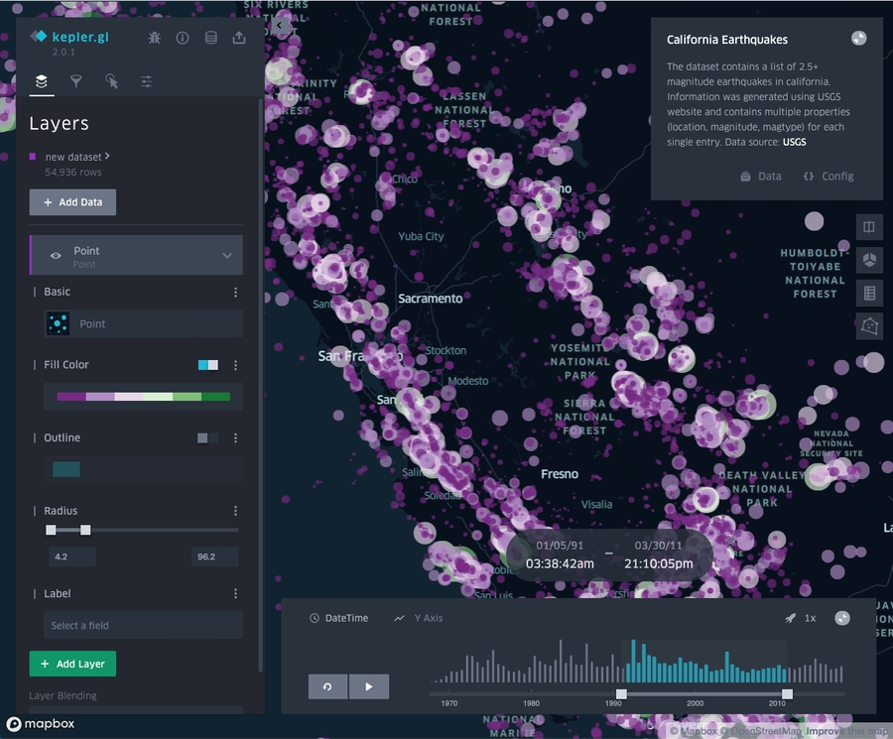
light
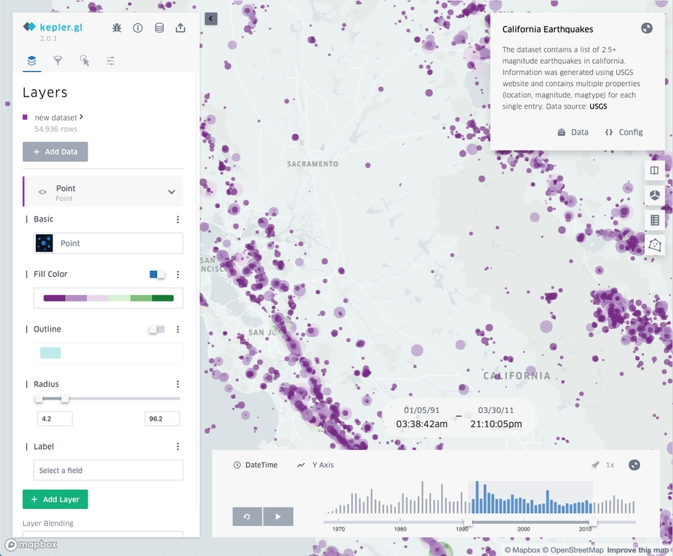
base

Localization
Kepler.gl supports localization through react-intl. Locale is determined by uiState.locale value. Current supported languages are:
locale code
Language
Default?
en
English
default
fi
Finnish
pt
Portuguese
ca
Catalan
es
Spanish
ja
Japanese
cn
Chinese
ru
Русский

Changing default language
By default the first language is English en. The default language can be changed by giving locale value to uiState:
Copy
import {combineReducers} from 'redux';
import keplerGlReducer from '@kepler.gl/reducers';
import {LOCALE_CODES} from '@kepler.gl/localization';

const customizedKeplerGlReducer = keplerGlReducer.initialState({
uiState: {
// use Finnish locale
locale: LOCALE_CODES.fi
}
});

const reducers = combineReducers({
keplerGl: customizedKeplerGlReducer,
app: appReducer
});

Adding new language
Let's say we want to add the Swedish language to kepler.gl. Easiest way to add translation of new language is to follow these 3 steps:
- Find out the language code for Swedish: sv
- Add new translation file src/localization/translations/sv.js by copying src/localization/translations/en.js and translating the strings
- Update LOCALES in src/localization/locales.js to include new language translation:
Copy
export const LOCALES = {
en : 'English',
fi : 'Suomi',
pt: 'Português',
// add Swedish language
sv: 'Svenska'
}

Modify default translation or add new translation
the localeMessages prop of KeplerGl takes additional translations and merge with default translation.

Example 1. Update default translation
To update the english translation of layerManager.addData, pass localeMessages like this.
Copy
const localeMessages = {
en: {
['layerManager.addData']: 'Add Data to Layer'
}
};

const App = () => (
<KeplerGl
id="map"
localeMessages={messages}
mapboxApiAccessToken={Token}
/>
);

Example 2. Pass additional translation
Sometimes together with dependency injection, you might need to add additional translations to the customized component. For example, adding an additional settings panel in the side panel, you will need to provide a translation for the panel name assigned to sidebar.panels.settings
Copy
const localeMessages = {
en: {
['sidebar.panels.settings']: 'Settings'
}
};

const App = () => (
<KeplerGl
id="map"
localeMessages={messages}
mapboxApiAccessToken={Token}
/>
);

